The Project Gutenberg EBook of Half Hours in Bible Lands, Volume 2, by
Rev. P. C. Headley

This eBook is for the use of anyone anywhere at no cost and with
almost no restrictions whatsoever. You may copy it, give it away or
re-use it under the terms of the Project Gutenberg License included
with this eBook or online at www.gutenberg.net

Title: Half Hours in Bible Lands, Volume 2
Patriarchs, Kings, and Kingdoms

Author: Rev. P. C. Headley

Release Date: May 7, 2008 [EBook #25363]

Language: English

Character set encoding: ASCII

*** START OF THIS PROJECT GUTENBERG EBOOK HALF HOURS IN BIBLE LANDS, VOL 2 ***

Produced by Don Kostuch

HALF HOURS IN BIBLE LANDS,

OR,

STORIES AND SKETCHES FROM THE SCRIPTURES AND THE EAST.

PATRIARCHS, KINGS, AND KINGDOMS.

BY REV. P. C. HEADLEY,
AUTHOR OF "THE WOMEN OF THE BIBLE,"
"HARVEST WORK OF THE HOLY SPIRIT,"
"THE EMPRESS JOSEPHINE,"
"MASSACHUSETTS IN THE REBELLION,"
ETC., ETC., ETC.

WITH NUMEROUS ILLUSTRATIONS.

PHILADELPHIA:
PUBLISHED BY JOHN E. POTTER & CO.,
No. 617 SANSOM STREET.
Entered according to Act of Congress, in the year 1867, by
JOHN E. POTTER & CO.,
In the Clerk's Office of the United States District Court
in and for the Eastern District of Pennsylvania.
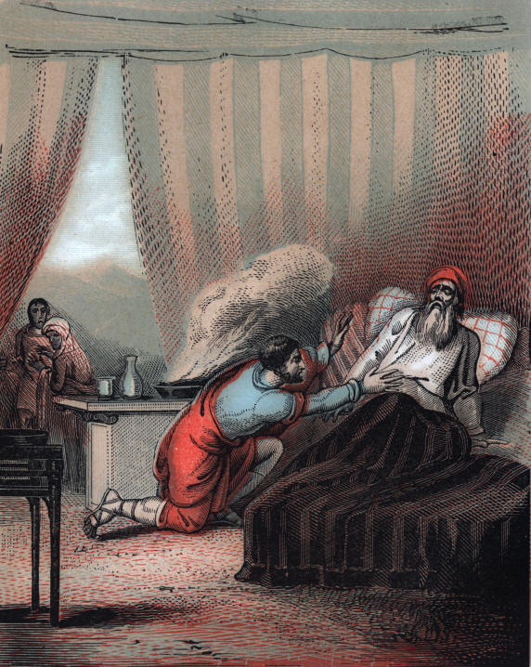
Isaac and Esau
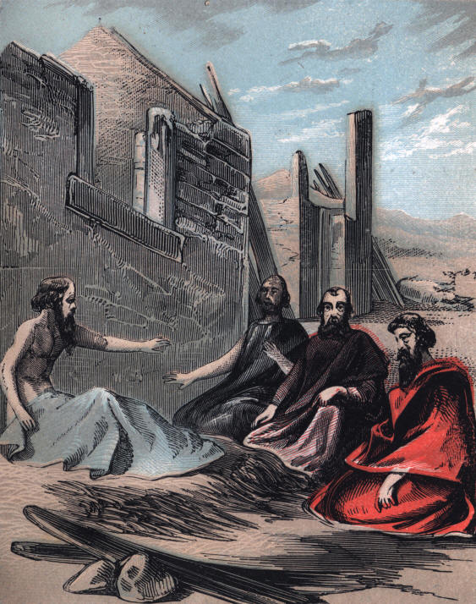
Job and His Three Friends
THE BIBLE AND THE HOLY LAND .

PATRIARCHS, KINGS, AND KINGDOMS.

SCENES IN THE LIVES OF THE PATRIARCHS.

The patriarchs might be called family kings--the divinely appointed rulers of households. They were the earliest sovereigns under God of which we have any account. Their authority was gradually extended by the union of households, whose retinue of servants was often large, and their wealth very great.
The founder and leader of the patriarchal line chosen by God from the wealthy nomades, or wandering farmers of the fruitful valleys, was Abram. A worshipper of the Infinite One, he married Sarai, a maiden of elevated piety and personal beauty. And doubtless they often walked forth together beneath the nightly sky, whose transparent air in that latitude made the stars impressively--

"The burning blazonry of God!"

3
PATRIARCHS, KINGS, AND KINGDOMS.

Upon the hill-tops around, were the observatories and altars of Chaldean philosophy, whose disciples worshipped the host of Heaven. In the serenity of such an hour, with the white tents reposing in the distance, and the "soul-like sound" of the rustling forest alone breaking the stillness, it would not be strange, as they gazed on flaming Orion and the Pleiades, if they had bowed with the Devotee of Light, while--

"Beneath his blue and beaming sky,
He worshipped at their lofty shrine,
And deemed he saw with gifted eye,
The Godhead in his works divine."

But a purer illumination than streamed from that radiant dome, brought near in his majesty the Eternal, and like the holy worshippers of Eden, they adored with subdued and reverent hearts, their infinite Father.
There is great sublimity and wonderful power in the purity and growth of religious principle, in circumstances opposed to its manifestation. The temptations resisted--the earnest communion with each other--the glorious aspirations and soarings of imagination, when morning broke upon the summits, and evening came down with its stars, and its rising moon, flooding with glory nature in her repose. These, and a thousand lovely and touching scenes of that pastoral life, are all unrecorded.

4
PATRIARCHS, KINGS, AND KINGDOMS.

The great events in history, and bold points in character, are seized by the inspired penman as sufficient to mark the grand outline of God's providential and moral government over the world, and his care of his people.
Just when it would best accomplish his designs, which are ever marching to their fulfillment, Jehovah called to Abram, and bade him go to a distant land which he would show him. With his father-in-law, and with Lot, his flocks and herds, he journeyed toward Palestine. When he arrived at Haran, in Mesopotamia, pleased with the country, and probably influenced by the declining health of the aged Terah, he took up his residence there. Here he remained till the venerable patriarch, Sarai's father, died. The circle of relatives bore him to the grave, and kept the days of mourning. But the dutiful daughter wept in the solitary grief of an orphan's heart. A few years before she had lost a brother, and now the father to whom she was the last flower that bloomed on the desert of age, and who lavished his love upon her, was buried among strangers.
Then the command to move forward to his promised inheritance came again to Abram. With Sarai he journeyed on among the hills, encamping at night beside a mountain spring, and beneath the unclouded heavens arching their path, changeless and watchful as the love of God--exiles by the power of their simple faith in him. Soon as they reached Palestine, Abram consecrated its very soil by erecting a family altar, first in the plain of Moreh, and again on the summits that catch the smile of morning near the hamlet of Bethel.

5
PATRIARCHS, KINGS, AND KINGDOMS.

Months stepped away, rapidly as silently, old associations wore off, and Abram was a wealthy and happy man in the luxuriant vales of Canaan. His flocks dotted the plains, and his cattle sent down their lowing from encircling hills. But more than these to him was the affection of his beautiful wife. Her eye watched his form along the winding way, when with the ascending sun he went out on the dewy slopes, and kindled with a serene welcome when at night-fall he returned for repose amid the sacred joys of home.
At length there came on a fearful famine. The rain was withholden, and the dew shed its benediction no more upon the earth. He was compelled to seek bread at the court of Pharaoh, or perish. Knowing the power of female beauty, and the want of principle among the Egyptian princes, he was afraid of assassination and the captivity of Sarai which would follow. Haunted with this fear, he told her to say that she was his sister--which was not a direct falsehood, but only so by implication. According to the Jewish mode of reckoning relationship, she might be called a sister; and Abram stooped to this prevarication under that terrible dread which, in the case of Peter, drove a true disciple of Christ to the brink of apostacy and despair.

6
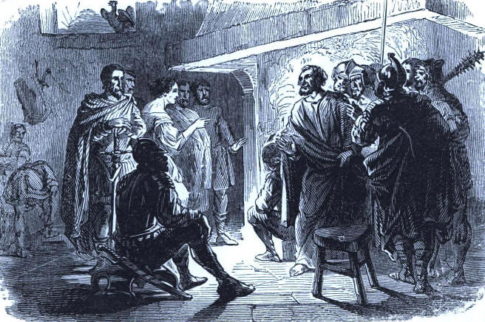
Results of Prevarication. Peter denying his Master

7
8
PATRIARCHS, KINGS, AND KINGDOMS.

But his deception involved him in the very difficulty he designed to escape. The king's courtiers saw the handsome Hebrew, and extolled her beauty before him. He summoned her to the apartments of the palace, and captivated by her loveliness, determined to make her his bride. During the agonizing suspense of Abram, and the concealed anguish of Sarai in her conscious degradation, the hours wore heavily away, until the judgment of God upon the royal household brought deliverance. Pharaoh, though an idolater, knew by this supernatural infliction, that there was guilt in the transaction, and called Abram to an account. He had nothing to say in self-acquittal, and with a strange magnanimity, was sent away quietly, with his wife and property, followed only by the reproaches of Pharaoh, and his own wakeful conscience.
Abram returned to Palestine, became a victor in fierce battles with a vastly outnumbering foe, and was in possession of a splendid fortune.
Whether in Egypt, or in his tent on the plains of Palestine, Abram, with all the patriarchs, was a true gentleman. We may doubt whether any modern school of refinement in manners could furnish any nobler examples of dignity and civility in personal learning and manners, than were the rich dwellers in ancient Palestine. Subjects fell prostrate before sovereigns; equals, when they met, inclined the head toward the breast, and placed the right hand on the left breast. Of the Great King it is written, "Come, let us bow down; let us worship before the Lord our Maker."

9
PATRIARCHS, KINGS, AND KINGDOMS.

Jehovah appeared to Abram in a glorious vision, talking with him as friend to friend. He fell on his face in the dust, as did the exile of Patmos ages after, while a voice of affection and hope carne from the bending sky: "I am the Almighty God; walk before me and be thou perfect." The solemn covenant involving the greatness and splendor of the people and commonwealth that should spring from the solitary pair, was renewed; and as an outward seal, he was named Abraham, The father of a great multitude--and his wife Sarah, The princess. Still he laughed at the absurdity that Sarah would ever be a mother, and invoked a blessing on Ishmael, but evidently said nothing to her upon a subject dismissed as incredible from his thoughts. For when the celestial messengers were in the tent, on their way to warn Lot, she listened to their earnest conversation, concealed by the curtains, and hearing that repeated promise based on the immutability of God, also laughed with bitter mirth at her hopeless prospect in regard to the marvelous prediction. And when one of the Angels, who was Jehovah veiled in human form, as afterward "manifest in the flesh," charged her with this unbelief and levity, the discovery roused her fears, and approaching him, without hesitation, she denied the fact. He knew perfectly her sudden apprehension, and only repeated the accusation, enforced by a glance of omniscience, like that which pierced the heart of Peter.

10
PATRIARCHS, KINGS, AND KINGDOMS.

The group separated, and two of those bright beings went to Sodom. The next morning Abraham walked out upon the plain, and looked toward the home of Lot. He saw the smoke as of a great furnace going up to the calm azure, from the scathed and blackened plains, where life was so busy and joyous a few hours before! With a heavy heart he returned to his tent, arid brought Sarah forth to behold the scene. She clung with trembling to his side, while she listened to the narration of the terrible overthrow of those gorgeous cities, and the rescue of her brother's household, and beheld in the distance the seething and silent grave of millions, sending up a swaying column of ebon cloud, like incense, to God's burning indignation against sin.
They left the vale of Mamre, and journeyed to Gera, where, with a marvellous forgetfulness of the past, the beauty of Sarah again led them into deception and falsehood, and with the same result as before. Abimelech, the king, would have taken her for his wife as Abraham's sister, had not God appeared in a dream, threatening immediate death. Upon pleading his innocence, he was spared, and expostulating with his guest, generously offered him a choice of residence in the land; but rebuked Sarah with merited severity.

11
PATRIARCHS, KINGS, AND KINGDOMS.

Prophecy and covenant now hastened to their fulfillment. Sarah gave birth to a son, and with the name of God upon her lips, she gave utterance to holy rapture. With all her faults, she was a pious and noble woman. She meant to train him for the Lord, and therefore when she saw young Ishmael mocking at the festival of his weaning, she besought her husband to send away the irreverent son, whose influence might ruin the consecrated Isaac. Hagar, with a generous provision for her wants, was a fugitive; and the Most High approved the solicitude of a mother for an only child, around whose destiny was gathered the interest of ages, and the hopes of a world.
And now, with the solemn shadows of life's evening hours falling around her, and a heart subdued by the discipline of Providence, in the fulness of love which had been rising so long within the barriers of hope deferred, she bent prayerfully over the very slumbers of that fair boy, and taught him the precious name of God with the first prattle of his infant lips. How proudly she watched the unfolding of this bud of promise!

12
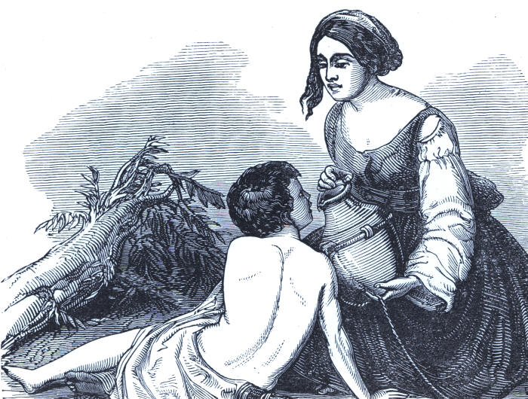
Hagar in the Wilderness.

13
14
PATRIARCHS, KINGS, AND KINGDOMS.

When, in the pastimes of childhood, he played before the tent door, or, with a shout of gladness, ran to meet Abraham returning from the folds, her calm and glowing eye marked his footsteps, and her grateful aspirations for a blessing on the lad, went up to the Heaven of heavens. At length he stood before her in the manliness and beauty of youth, unscarred by the rage of passions, and with a brow open and laughing as the radiant sky of his own lovely Palestine.
It was a morning which flooded the dewy plains with glory, and filled the groves with music, when Abraham came in from his wonted communion with God, and called for Isaac, and told him to prepare for a three days' journey in the wilderness. How tenderly was Sarah regarded in this scene of trial! Evidently no information of the awful command to sacrifice the son of her old age was made to her. She might have read something fearful in the lines of anxious thought and the workings of deep emotion in the face of Abraham. But he evaded all inquiries on the subject, "clave the wood," and accompanied by two of his young men, turned from his dwelling with a blessing from that wondering mother, and was soon lost from her straining vision among the distant hills. Upon the third day he saw the top of Mount Moriah kindling in the rising sun, and taking Isaac alone, ascended to the summit, whereon was to be reared an altar, which awakened more intense solicitude in heaven, than any offering before or since, except on Calvary, where God's "only be-gotten and well-beloved Son" was slain. There is no higher moral sublimity than the unwavering trust and cheerful obedience of this patriarch, when the very oath of the Almighty seemed perjured, and the bow of promise blotted from the firmament of faith!

15
PATRIARCHS, KINGS, AND KINGDOMS.

But he believed Jehovah, and would have clung to his assurance, though the earth had reeled in her orbit, and every star drifted from its moorings. He prayed for strength, with his hand on the forehead of his submissive son.

"He rose up, and laid
The wood upon the altar. All was done,
He stood a moment--and a deep, quick flush
Passed o'er his countenance; and then he nerved
His spirit with a bitter strength, and spoke--
'Isaac! my only son'--the boy looked up,
And Abraham turned his face away, and wept.
'Where is the lamb, my father?' O, the tones,
The sweet, the thrilling music of a child!
How it doth agonize at such an hour!
It was the last, deep struggle--Abraham held
His loved, his beautiful, his only son,
And lifted up his arm, and called on God
And lo! God's angel staid him--and he fell
Upon his face and wept."

16
PATRIARCHS, KINGS, AND KINGDOMS.

The years fled, the good old Abraham died, and Isaac succeeded him to the patriarchal honors. He had two sons, Esau and Jacob. The elder brother was irreligious, and married a heathen wife. God had rejected him, and promised to Jacob the birthright; in other words, he was to be the chief patriarch, through whose descendants the Messiah should come. He was his mother's favorite boy, while Isaac clung to Esau.
When the fond father became weak and blind from age, feeling that death was near, one day he called Esau, and told him as he might die suddenly, to get him venison, and prepare for the solemn occasion of receiving his parting blessing, which should secure the privileges and pre-eminence of the first-born. The hunter went into the fields, and Rebekah recollected that Jacob had purchased the birthright of his brother for a mess of pottage one day when he came in from the chase faint with hunger and exhaustion. She determined by a stroke of management to secure the patriarchal benediction. She sent him to the flocks after two kids, which were prepared with the savory delicacy his father loved, dressed him up in Esau's apparel, covering his hands and neck to imitate the hairiness of the rightful heir, and sent him to the beside of the dying Isaac. When the patriarch inquired who he was, he replied, "I am Esau, thy first-born."

17
PATRIARCHS, KINGS, AND KINGDOMS.

This was beyond belief, because even the skillful hunter could scarcely, without a miracle, so soon bring in the game, and dress it for his table. Jacob was called to his side, and he felt of his hands; the disguise completed the delusion, although his voice had the milder tone of the young shepherd to that father's ear. He repeated the interrogation concerning his name, then embracing him, pronounced in a strain of true poetry, the perpetual blessing of Jehovah's favor upon his undertakings, and his posterity. The stratagem had succeeded, and Jacob hastened to inform his mother of the victory, just as Esau entered. When Isaac discovered the mistake, he trembled with excitement, while his son cried in anguish, "Bless even me also, O my father!" That cry pierced the breaking heart of the aged man, but it was a fruitless lament, He was inflexible, and Esau wept aloud over his blasted hopes; plotting at the same time, in his awakened enmity, the murder of Jacob.
This scene of deception, disappointment, and providential working, the introductory picture brings vividly before us.
The patriarchs were generally shepherds, and when we read in the Bible of shepherds, we have but a poor impression of their business, if we think only of the keeping of the small flocks kept in the fenced fields and yards of modern farmers. They made their wealth chiefly by feeding immense flocks and herds.

18
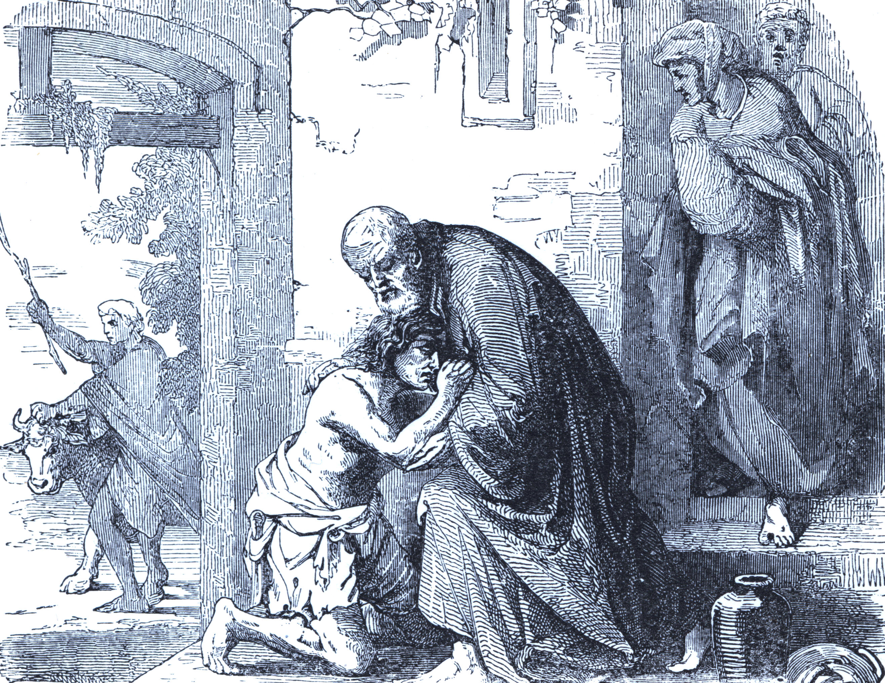
The Welcome to a Wayward Son

19
20
PATRIARCHS, KINGS, AND KINGDOMS.

They had extensive open plains; and were obliged to watch the animals to prevent their being lost, stolen by robbers, or devoured by ferocious beasts. When it was at all safe, the shepherds and their flocks slept in the fields, beneath the open sky, or under the sheltering trees.
If the country was infested by dangerous men or animals, the owners of the flocks built the fold or sheep-cote. This enclosure was sometimes merely a rude pen. The walls were of wood or stone, with a thatched roof--if they had any at all. The shepherd follows a wayward sheep, and brings him back to a place of safety.
Thus the Good Shepherd of souls, whose disciples, like the flocks of the East, "know his voice," with his rod of affliction restrains the wandering and keeps securely the trusting ones.
Occasionally a rich land owner would make an expensive fold--a kind of town or fortress for his flocks. Keeping the sheep in the air, it was believed improved the texture of the wool, making it softer and firmer than when exposed to the sweating and vapors which would necessarily result from crowding them often and long into enclosures.
Abraham, Isaac, and Jacob, were among the richest shepherds of antiquity, and stand alone in moral grandeur of character, so far as we have any records of the Hebrew husbandmen.

21
PATRIARCHS, KINGS, AND KINGDOMS.

The great enemy of the sheep the world over, is the wolf--a cunning, savage, and daring creature. A lamb of the flock seems to be a dainty feast for him. He relishes even a child; the human delicacy is quite as delicious as the other. A mother, with three children, was once riding in a sledge in a desolate region, when a pack of wolves came running after her. She drove rapidly on, but they came nearer and nearer, until their hot breath fell on her face. In her terror, she threw one of the children to the hungry wolves, hoping thus to pacify or check them until she could get out of their reach. Soon, however, they came galloping on, surrounding her sledge, and she flung another upon the snow. A brief delay, and they were once more around her, and the last child was given to the beasts; and then she reached her home in safety.
When she told the story to her neighbors, an exasperated peasant hewed her down with an axe, because she fed the wolves on her own offspring, selfishly saving by the sacrifice, her own life.
How like the destroyers of human virtue, and the great destroyer himself! Wolves in sheep's clothing, stealing upon unguarded victims, and glorying in the destruction of all that is "lovely and of good report." for the transitory present and endless future!

22
PATRIARCHS, KINGS, AND KINGDOMS.

We now turn to the annals of a patriarchal life which is entirely new, and intensely interesting--the only record of the kind in the Bible.
The inspired history introduces him in the following words: "There was a man in the land of Uz, whose name was Job." This region was in Eastern Arabia, and probably near the home of Abram when he was summoned by God to leave his idolatrous friends and neighbors in "Ur of the Chaldees."
It is thought he lived not far from the time of the great founder of the Hebrew patriarchy. Job was probably a descendant of Nahor, Abram's brother. He was a devout, rich, and benevolent Gentile patriarch. The princely fortune of this "greatest of all the men of the East," is indicated by an inventory of his flocks and herds. He had "seven thousand sheep, and three thousand camels, and five hundred yoke of oxen, and five hundred she asses." His household was also "very great." This mighty man was a humble servant of God; and Satan could not bear to see his influence and prosperity; and he determined to make him the shining mark of his enmity to God and man.
The mysterious account of his entrance upon the cruel work of attempted ruin, is in the following words: "Now there was a day when the sons of God came to present themselves before the Lord, and Satan came also among them."

23
PATRIARCHS, KINGS, AND KINGDOMS.

The saints of that early age were called "Sons of God," but the meaning seems to be that either Satan was permitted to appear in a gathering of angels who, returning from their ministries of love, were reporting to their king, and awaiting new instructions, or, it is designed only to represent the real character and power of the tempter, in contrast with the loyalty of God's servant.
The whole narrative bears the marks of a real history; and Jehovah is not limited by our ideas of what he can consistently do. "My ways are not your ways, nor my thoughts your thoughts, saith the Lord."
The devil charged Job with selfish motives in serving God. He could afford to be religious with such rare and splendid prosperity. To show to the universe Satan's lying malice, his loyal subject's holy character, and to comfort his people in all the ages following, while the discipline purified and beautified the sufferer, he told the adversary to try the patriarch with a change of circumstances--the severest trials; only his body must not be touched.
The gratified fiend hastened away to his attack upon the unsuspecting friend of God, over whom he anticipated a great victory. The patriarch's family was large, and evidently a united and happy one. They had their anniversary festivals, which were hallowed by religious services; the faithful and affectionate father offering sacrifices on such occasions.

24

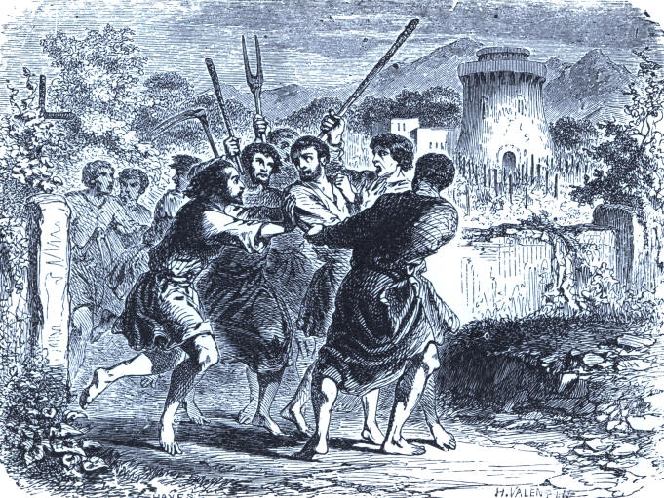
The Cruel Husbandman

25
26
PATRIARCHS, KINGS, AND KINGDOMS.

The Lord was recognized amid the most joyful scenes of social life; and not, as in many prosperous households of Christian name in all the ages since, excluded from the circle of pleasure like an unwelcome, unworthy guest.
The birthday seems to have been the favorite anniversary; and at the very moment Satan left Jehovah, the children were assembled at the house of the oldest brother. Job was not there. He may have gone away for awhile, or not yet have joined the rejoicing company.
For a messenger rushed into his presence with the startling intelligence that the lawless Sabeans living in the region, had fallen upon the servants keeping the oxen and asses, and slaying them, had taken the animals away. No sooner had the devil obtained permission to engage, in the wicked enterprise, than he found ready agents among men. And before the evil report was finished, another terrified, excited servant, came in, saying that the lightning of heaven had consumed the seven thousand sheep.
This intelligence was falling from the lips of the only shepherd who escaped the devouring fire, when a third messenger entered, pale with alarm, and announced the raid of three companies of Chaldeans upon the keepers of the three thousand camels, killing all but the bearer of the news, and driving off the beasts of burden.

27
PATRIARCHS, KINGS, AND KINGDOMS.

The trembling man was interrupted by the sudden appearance of the fourth servant, wild with terror, crowning the crushing tidings already received, by telling Job that a gale from the wilderness had swept down upon the eldest son's dwelling, where the whole family were, excepting the patriarch, and thrown walls and roof into a common wreck, burying his ten children under the fragments.
We cannot easily imagine the stunning effect of these reports, following each other like successive claps of thunder from a cloudless sky. Satan was watching the effect, ready to exult over the first expression of repining and rebellion. But how sublime the resignation of the loyal heart of the childless, homeless, and penniless sufferer! After the eastern custom in time of affliction, he cut off his hair, rent his robe, fell upon the ground, and worshipped. The lips, tremulous with sorrow, uttered the often-quoted and beautiful words: "The Lord gave, and the Lord hath taken away; blessed be the name of the Lord." No disloyal act, or foolish complaint against Jehovah, gratified the expectant enemy of God and man. But Satan was not satisfied with the trial of faith. He was allowed to appear before God, and in answer to the questioning respecting the patriarch's lofty yet meek submission, basely and meanly declared that if he had been permitted to torture the body, he should have succeeded in proving Job to be a hypocrite. The Lord had purposed to silence the devil, and thoroughly try and sanctify his own child. So he told the tempter to do what he pleased, only he must spare life.

28
PATRIARCHS, KINGS, AND KINGDOMS.

Suddenly poor Job was covered with burning ulcers, which defiled his form until he scraped it with a piece of broken pitcher. While sitting in the dust, a wretched mass of corruption, he found a new tempter in the person of his wife: She asked him if he could still "retain his integrity," and urged him to "curse God and die." Beautifully again his breaking heart uttered its loyalty. Charging her with folly, he inquired: "What! shall we receive good at the hand of God, and shall we not receive evil?"
The scene of sorrow is now changed. Job had three friends living in the country not far off, who were clearly intelligent, noble men. They heard of his calamities, and started on a visit of condolence. When they came in sight of him, he was so changed that at first they did not know him. They wept aloud, rent their robes, and scattered dust on their heads, to express their overwhelming grief. There he sat, in miserable poverty and disease, and all around him the ruins of his just before magnificent fortune, and the bodies or graves of his sons and daughters. They approached him, and could say nothing, but sat down with him seven days and nights without speaking a word--an awful, expressive silence.

29
PATRIARCHS, KINGS, AND KINGDOMS.

At length Job could refrain no longer, but in his despondency, began to bewail his birth, and wish he had at least died in earliest infancy. Then was opened a long, eloquent, and wonderful discussion by the mourning company upon the providence and grace of God.
Jehovah at length spake from the rolling cloud, borne on the "wings of the wind," and indicated his dealings with a fallen race, pointing the debaters for illustrations of power, wisdom, and glory, to his works of creation, from the "crooked serpent" to "Orion and the Pleiades," floating in the nightly sky--the wonders of ocean, earth, and air.
Among the animals to which reference is made, there are three conspicuous ones, about which naturalists disagree--they cannot certainly tell us what they were. These are the unicorn, supposed by many to be the rhinoceros of the present day; the behemoth, thought to be the hippopotamus or river-horse; and the leviathan, which answers very well to the whale.
The description of the war horse is the finest ever written, and given in a few words; and yet he had not been seen amid the wildest storm of battle, bearing his rider to the flaming mouths of ordnance, and through the leaden hail of numberless infantry arms.

30
PATRIARCHS, KINGS, AND KINGDOMS.

"Hast thou given the horse strength? hast thou clothed his neck with thunder? Canst thou make him afraid as a grasshopper? the glory of his nostrils is terrible. He paweth in the valley, and rejoiceth in his strength, he goeth on to meet the armed men. He mocketh at fear, and is not affrighted; neither turneth he back from the sword. The quiver rattleth against him, the glittering spear and the shield. He swalloweth the ground with fierceness and rage: neither believeth he that it is the sound of the trumpet. He saith among the trumpets, Ha, ha; and he smelleth the battle afar off, the thunder of the captains, and the shouting."
He alludes to a very beautiful wonder of his forming skill--"the treasures of the snow." Few persons imagine the marvels of the fleecy storm that whiten the earth in winter. What a variety of perfect crystals! and how delicate their form and finish! The ice is made of crystals, and often gives out aeolion music at the touch of winter. Even the frost makes fine drawings on the window panes of leaves and flowers.
But the people of Palestine and the regions around it, know little of our northern winters. The cold season is brief, and the occasional snow storms light, and of short duration.
After God had finished his sublime appeal, Job bowed his head low before him, and declared that all he had known of him before, compared with what he had learned since he was afflicted, was no more than hearing about him; "for," he added, "now mine eye seeeth thee; wherefore I abhor myself, and repent in dust and ashes."

31
PATRIARCHS, KINGS. AND KINGDOMS.

Then the Lord rebuked Job's friends, because they had judged him harshly, and "had multiplied words without knowledge," directing them to offer a sacrifice for him.
The patriarch prospered again under Jehovah's smile, and became greater in wealth, and family, and influence, than he was when Satan assailed him. The deceiver and persecutor does not appear again in the annals of the devout Arabian; disappointed and enraged, he turned his malice against others more easily conquered and led captive by his wiles.
How awakening the thought that he still goes about "as a roaring lion, seeking whom he may devour." But with loving trust in God, he can only repeat his fruitless effort to destroy, preparing the way for richest blessings.

32
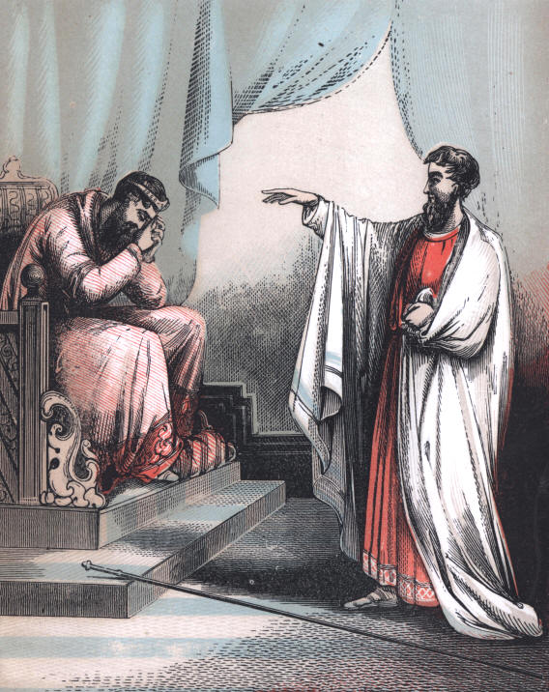
Nathan Reproving David.
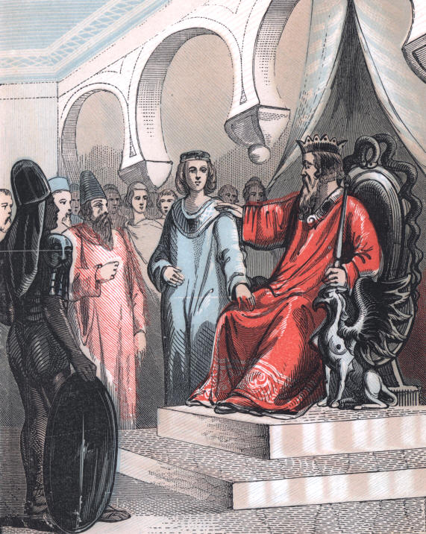
David's Charge to Solomon
THE BIBLE AND THE HOLY LAND.

PATRIARCHS, KINGS, AND KINGDOMS.

THE FIRST KINGS.

Theocracy, we have seen, was the first form of government in the world.
The word is from Theos, which means God; for He ruled by direct command, and would have continued to have been the only and perfect sovereign, had not man been disloyal to him.
The patriarchal quay, which was that of the family, having at length united households and extended authority, was still a Theocracy.
When God made his people a separate nation, each of the twelve tribes, which sprang from the sons of Jacob, had its own ruler. If any important matter concerning them all demanded public attention, they called an assembly of their leaders.
When the bondage in Egypt was broken, Moses was the deliverer and lawgiver of Israel, and Joshua the great general or military chieftain.

33
PATRIARCHS, KINGS, AND KINGDOMS.

The high priest was the visible servant of God--his representative of the Redeemer of his people.
Then came the judges, who were a kind of governors, having power to declare war and make peace for the nation, but wearing no badges of distinction. Jehovah revealed through them his will, and was still the glorious king of Israel.
With the increase in numbers and general prosperity, there was a decrease of the religious element and of harmony among the people. They also ceased to appreciate the simple and sublime principles of a Theocracy, while all around them was the central power and the pomp of pagan monarchies; and they became tired of God's holy sovereignty, having no visible display of authority. There were dissensions and civil strife in Israel, in consequence of these departures from the Lord, and strange melancholy blindness to their preeminence over other nations.
It was with them as it will be in the great American Republic, if Puritan faith and works decline, until practical atheism prevails in our "goodly land." The people will throw off wholesome restraints, become divided North and South, and corrupt in morals, until a monarchy will be the natural resort of the people, as a protection against their own selfish passions and conflicts.

34
PATRIARCHS, KINGS, AND KINGDOMS.

Samuel, the wonderful child of Elkanah and Hannah, given to them, like Jephthah and Samson, as a special mark of divine favor, and who early entered the temple-service under Eli, was the last of the judges, excepting the authority which he delegated to his sons. He was a noble, dutiful and devout boy, and a faithful priest and magistrate in Israel. Eli, whose sons were dissipated, and slain by God's revealed purpose on account of their enemies, preceded him, so that Samuel saw the last of the Theocracy, and inaugurated by the Lord's command a monarchy in Palestine.
The Hebrews came to him begging for a king, and urging, as one reason for the change, the unfitness of his sons to succeed him. They were mercenary and open to bribery, and it is not strange that they were disliked by the people. It is one of many instances of departure by children from the counsels and prayers of the kindest parents, and choosing the "wages of sin."
Samuel took the petition of the people to God for direction in answering it. The Lord's message was the following:
"Hearken to the voice of the people in all that they say to thee: for they have not rejected thee, but they have rejected me, that I should not reign over them. According to all the works which they have done, since the day that I brought them out of the land of Egypt, even to this day, wherewith they have forsaken me, and served other gods, so do they also to thee. Now, therefore, hearken to their voice: nevertheless testify solemnly to them, and show them the practice of the king that shall reign over them."

35
PATRIARCHS, KINGS, AND KINGDOMS

He then enumerated the burdens of the state which they must bear. The inventory of these royal exactions is so true to the experience of all countries under kingly rule, you will read it with interest. It was the first divine statement of the nature of a monarchy, and has needed no important change in the progress of the ages. Jehovah told Samuel to repeat the following description of the desired blessing, a king:
"He will take your sons and appoint them for himself, for his chariots, and to be his horsemen; and some shall run before his chariots. And he will appoint him captains over thousands, and captains over fifties; and will set them to ear his ground, and to reap his harvest, and to make his instruments of war and instruments of chariots. And he will take your daughters to be confectioners, and to be cooks, and to be bakers. And he will take your fields, and your vineyards, and your olive-yards, even the best of them, and give them to his servants. And he will take the tenth of your seed, and of your vineyards, and give them to his officers, and to his servants; and he will take your men-servants, and your maid-servants, and your goodliest young men, and your asses, and put them to his works. And he will take the tenth of your sheep: and ye shall be his servants. And ye shall cry out in that day, beware of your king which ye shall have chosen you; and the Lord will not hear you in that day."

36
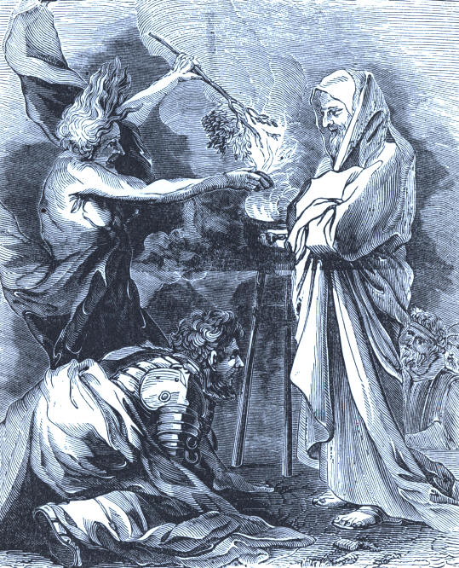
Saul and the Witch of Endor.

37
38
PATRIARCHS, KINGS, AND KINGDOMS.

God had selected the first monarch of earth outside of heathenism. In the comparatively small tribe of Benjamin, was a man of honorable ancestry named Kish. His son, Saul, was a splendid young man, and would have attracted admiring attention anywhere, and in any land under the sun, then or since his day. He was taller from his shoulders than all the rest of Israel's men, and possessed of the highest style of manly beauty. Repeated mention is made of his noble figure and bearing. The providential circumstances which attended his promotion were remarkable.
He had wandered about for three days seeking the strayed asses of his father. Fatigued with the unsuccessful search, he was inclined to abandon it and return home, when, finding himself near Ramah, where Samuel lived, he resolved to consult one who was renowned in all Israel as a man from whom nothing was hid. Instructed in the divine designs regarding Saul, the prophet received him with honor. He assured him that the asses which he had sought were already found, and invited him to stay with him until the next morning.

39
PATRIARCHS, KINGS, AND KINGDOMS.

Saul was in fact the man on whom the divine appointment to be the first king of Israel had fallen. A hint of this high destiny produced from the astonished stranger a modest declaration of his insufficiency. But the prophet gave him the place of honor before all the persons whom--foreknowing the time of his arrival--he had invited to his table. As is still usual in summer, Saul slept on the flat roof of the house; and was called early in the morning by Samuel, who walked forth some way with him on his return home. When they had got beyond the town they stopped, and Samuel then anointed Saul as the person whom God had chosen to be "captain over his inheritance;" and gave him the first kiss of civil homage. In token of the reality of these things, and to assure the mind of the bewildered young man, the prophet foretold the incidents of his homeward journey, and, in parting, desired his attendance on the seventh day following at Gilgal.
On the day and at the place appointed, Samuel assembled a general convocation of the tribes for the election of a king. As usual, under the Theocracy, the choice of God was manifested by the sacred lot. The tribe of Benjamin was chosen; and of the families of Benjamin, that of Matri was taken; and, finally, the lot fell upon the person of Saul, the son of Kish. Anticipating this result, he had modestly concealed himself to avoid an honor which he so little desired. But he was found and brought before the people, who beheld with enthusiasm his finely developed form and preeminence in appearance, and hailed him as their king.

40
PATRIARCHS, KINGS, AND KINGDOMS.

Many prominent persons of the great tribes were jealous and indignant, because the smallest tribe, and a young man whose chief claim to the honor was his fine figure, had been chosen. They refused to join the masses in their homage, and Saul displayed his shrewdness in "holding his peace."
And the wisdom of God was apparent in the result; for he gradually united the discordant elements around him, and became established in power. Soon after came the trial of his ability as a general.
The Ammonites, a mighty and warlike people under king Nahash, besieged the important town of Jabesh-Gilead. The beleaguered place was at length compelled to ask terms of capitulation. The proud and cruel reply was, that every man should have his right eye put out.
The Jabesh-Gileadites agreed to the hard conditions, unless help reached them within seven days. Messengers hastened to Saul, in Gibeah, and found him returning from his herds in the field. The story of the invasion and peril roused all the energies and martial spirit of a king worthy of his crown. It was the Lord's inspiration for his high office, and immediate command of the army.

41
PATRIARCHS, KINGS, AND KINGDOMS

The inhabitants were timid; and to awaken their courage he slew oxen, had them quartered, and sent the pieces over the kingdom, assuring those who were able to fight, that unless they hastened to the rescue all their cattle should have a similar slaughter. The volunteers came pouring in, and Saul marched to Jabesh-Gilead. A battle followed, and the Ammonites were routed with terrible slaughter. It was a grand victory, and won for Saul the glory of military genius. This settled the question of his right to reign, and his sceptre was held over an undivided people.
Retaining three thousand men, he followed up the conquest by an attack upon the Philistines, who had conquered on the south, and deprived Israel of weapons of war, and implements of husbandry. Only Saul and Jonathan had either sword or spear. The latter, a gifted and noble young man, distinguished himself, under God's special benediction, in a successful assault upon a garrison of the Philistines. The enemy rallied in full strength, and Saul prepared to meet them with additional forces.
Samuel had appointed sacrifices to be made before the campaign was opened, and because he did not appear in Gilgal when Saul expected him, the king turned priest, and presented the offerings. This rashness revealed his undevout character and haughty self-will, which proved his ruin.

42
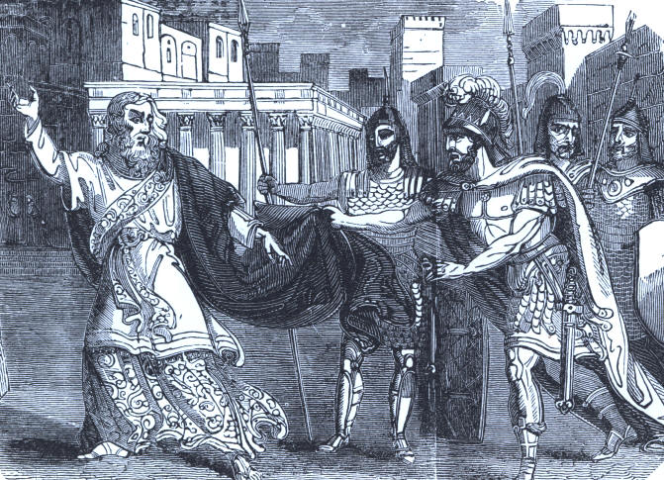
Saul Rejected

43
44
PATRIARCHS, KINGS, AND KINGDOMS.

Meanwhile the most of his troops had scattered, through fear of the powerful foe. But Jonathan determined to make a bold onset, and, with his armor-bearer, climbed a high cliff, and fell upon the Philistines. They supposed the Hebrews were rushing from ambush upon them, and began to fly. Saul entered the field and aided in the overthrow of the defeated warriors, slaying and treading each other down in the wild confusion of the retreat.
During the last years of Saul's reign, conscious that God had forsaken him, in one of his campaigns against the Philistines he sought the counsel of a witch. When he beheld the vast force which the Philistine states had, by a mighty effort, brought into the field, dire misgivings as to the result arose in his mind; and now, at last, in this extremity, he sought counsel of God. But the Lord answered him not by any of the usual means--by dreams, by Urim, or by prophets. Finding himself thus forsaken, he had recourse to a witch at Endor, not far from Gilboa, to whom he repaired by night in disguise, and conjured her to evoke the spirit of Samuel, that he might ask counsel of him in this fearful emergency. Accordingly, an aged and mantled figure arose, which Saul took to be the ghost of Samuel, though whether it were really so or not has been much questioned.

45
PATRIARCHS, KINGS, AND KINGDOMS.

The king bowed himself reverently, and told the reason for which he had called him from the dead. The figure, in reply, told him that God had taken the crown from his house, and given it to a worthier man; that, on the next day, the Philistines would triumph over Israel; and that he and his sons should be slain in the battle. The king swooned at these heavy tidings, but soon recovered, and, having taken some refreshment, returned the same night to the camp.
The engraver's art has produced a picture of this strange scene, one which cannot be clearly and satisfactorily explained.
Saul received orders, through Samuel, to execute the Lord's "fierce wrath" upon the Amelekites, who had formerly been doomed to utter extermination, for opposing the Israelites when they came out of Egypt. The result of the war put it fully in the king's power to fulfil his commission; but he retained the best of the cattle as booty, and brought back the Amalekite king Agag as a prisoner. Here Saul again ventured to use his own discretion where his commission left him none. For this the divine decree, excluding his descendants from the throne, was again and irrevocably pronounced by Samuel, who met him at Gilgal on his return. The stern prophet then directed the Amalekite king to be brought forth and slain by the sword, after which he departed to his own home, and went no more to see Saul to the day of his death, though he ceased not to bemoan his misconduct, and the forfeiture it had incurred.

46
PATRIARCHS, KINGS, AND KINGDOMS.

The next engraving is a very good view of this crisis in Saul's destiny--his rejection by God and his prophet. When Samuel turned to leave the king, the terrified ruler seized his mantle, and in the struggle it was torn. The prophet improved the incident by telling him that thus should his kingdom be rent from him, and given to a neighbor.
We cannot follow Saul through all the achievements and crimes of his eventful reign; the abandonment of him by the grieved and indignant Samuel; his deceptive prosperity; and his conscious desertion by God, until his fits of depression bordered on madness. He had genius and heroism, but a bad heart, and the hour of his overthrow drew near.
The venerable and gifted prophet who anointed the king was commanded by Jehovah to consecrate the successor to the throne. He was directed to go to Bethlehem, and there anoint one of the sons of Jesse. He knew that should Saul be informed of the errand, his days were numbered. The doom of a traitor would follow the solemn act.
To protect his servant the Lord told Samuel to offer a sacrifice, and tell the king he was going to Bethlehem for the purpose.

47
PATRIARCHS, KINGS, AND KINGDOMS.

When Samuel reached Bethlehem, he laid the offerings upon the altar, and invited a worthy citizen and his family to the sacrifice. The good man's name was Jesse, and he had eight sons. Eliab, the eldest, like Saul, was fine-looking--tall, athletic, and commanding in his personal appearance. Samuel thought he must be the future king of Israel; but God revealed to him his mistake. Six brothers followed him in their presentation to the prophet, and the Lord gave the same intimation of his will he had respecting Eliab.
The man of God was perplexed. What could he do, if these were the only sons of Jesse, as it seemed, for no more came? It occurred to him, however, that possibly there might be another boy, and he inquired of Jesse if it were not so.
The excellent father had sent the youngest son, about fifteen years old, to keep the sheep, and it did not even enter his mind that this mere child could have any thing to do with the affairs of the kingdom. He stated the facts to Samuel, who immediately desired to see the lad. He was sent for, and soon stood before the prophet. The patriarchal servant of the Infinite One looked upon the noble boy, with his "ruddy and beautiful countenance," and saw in him the next monarch of Israel.

48
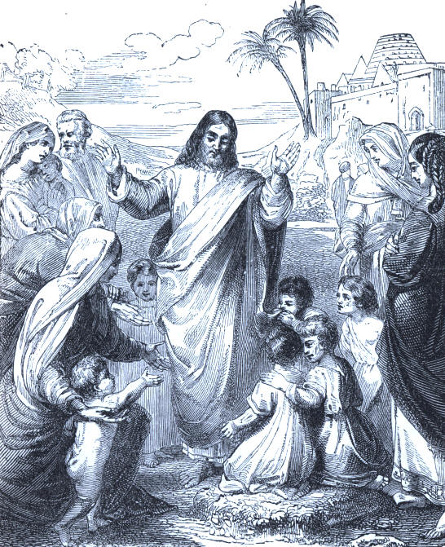
Christ Blessing Little Children.

49
50
PATRIARCHS, KINGS, AND KINGDOMS.

David stood among his brethren, a modest, bewildered shepherd boy, uninjured by unholy gratification of passion and appetite--a pure-minded, manly, and devout youth.
God told Samuel to anoint him, and he poured the consecrating oil upon the fair brow of the astonished David. Then the Spirit of the Lord came upon him, and departed from Saul altogether. The juvenile shepherd and hero, who had slain a lion and a bear, in defence of his sheep, returned to his flocks, a king in destiny.
Remorse, the predictions of Samuel against him, and baleful passions, made Saul so wretchedly melancholy, that some of his attendants suggested to the monarch that he should try the soothing effect of music. The proposition was favorably received, and upon the recommendation of another friend, David, the son of Jesse, of whom Saul knew nothing before, was sent for to play upon the harp. The young minstrel won the respect and affection of the royal household, and his harpings were the principal solace of the infatuated and gloomy king, who at length made David his armor-bearer.
You know the warriors of ancient time wore armor made of metal to protect the body from the spear and sword, the common weapons of the battle-field; and men were appointed by monarchs to have the care of it.

51
PATRIARCHS, KINGS, AND KINGDOMS.

Since their last great discomfiture, the Philistines had recruited their strength, and in the thirtieth year of Saul's reign, and the twentieth of David's life, they again took the field against the Israelites. It curiously illustrates the nature of warfare in those times, to find that the presence, in the army of the Philistines, of one enormous giant, about nine or ten feet high, filled them with confidence, and struck the Israelites with dread. Attended by his armor-bearer, and clad in complete mail, with weapons to match his huge bulk, the giant, whose name was Goliah, presented himself daily between the two armies, and, with insulting language, defied the Israelites to produce a champion who, by single combat, might decide the quarrel between the nations. This was repeated many days; but no Israelite was found bold enough to accept the challenge. At length David, who had come to the battle-field with food for his brethren, no longer able to endure the taunts and blasphemies of Goliah, offered himself for the combat. The king, contrasting the size and known prowess of the giant with the youth and inexperience of Jesse's son, dissuaded him from the enterprise. But as David expressed his strong confidence that the God of Israel, who had delivered him from the lion and the bear, when he tended his father's flock, would also deliver him from the proud Philistine, Saul at length allowed him to go forth against Goliah. Refusing all armor of proof, and weapons of common warfare, David advanced to the combat, armed only with his shepherd's sling, and a few smooth pebbles picked up from the brook which flowed through the valley.

52
PATRIARCHS, KINGS, AND KINGDOMS.

The astonished giant felt insulted at such an opponent, and poured forth such horrid threats as might have appalled anyone less strong in faith than the son of Jesse. But as he strode forward to meet David, the latter slung one of his smooth stones with so sure an aim and so strong an arm, that it smote his opponent in the middle of the forehead, and brought him to the ground.
The praises of the people lavished on David excited Saul's jealousy, and he sought in various ways to kill David, who seemed to have a charmed life; for God was with him, and no blow aimed at his life was successful.
The king's son, Jonathan, loved David devotedly, and more than once saved him from the wrath of Saul.
After hunting the son of Jesse, consulting witches in his desperation, and fighting the Philistines in bloody conflicts, near Mount Gilboa, defeated and wounded, he committed suicide by falling on his sword. Thus ended the career of the first king of the Hebrew nation.
David, under divine guidance, went to Hebron, and was there publicly anointed king by the tribe of Judah. But Abner, a splendid general, and a great friend of Saul, induced the rest of the tribes to acknowledge Ishbosheth, the only son of Saul then living, as their sovereign. Soon, however, a quarrel with his protege, led him to join David, who was at length proclaimed king by all the people.

53
PATRIARCHS, KINGS, AND KINGDOMS.

After years of prosperity in war and peace, he had a sanguinary battle with the Ammonites. This occurred in the eighteenth year of his reign. The conduct of this war David intrusted to Joab, and remained himself at Jerusalem. There, while sauntering upon the roof of his palace, after the noonday sleep, which is usual in the East, he perceived a woman whose great beauty attracted his regard. She proved to be Bathsheba, the wife of Uriah, an officer of Canaanitish origin, then absent with the army besieging Rabbah, the capital of Ammon. David was so fascinated with her that he determined to add her to his royal household. He sent for Uriah to Jerusalem. Having heard from him the particulars of the war, which he pretended to require, the king dismissed him to his own home. But Uriah, feeling that it ill became a soldier to seek his bed while his companions lay on the hard ground, under the canopy of heaven, exposed to the attacks of the enemy, remained all night in the hall of the palace with the guards, and returned to the war without having seen Bathsheba. David made him the bearer of an order to Joab to expose him to certain death, in some perilous enterprize against the enemy. He was obeyed by that unscrupulous general; and when David heard that Uriah was dead, he sent for Bathsheba, and made her his wife. He had already several wives, as was customary in those times; and among them was Michal, whom he had long ago reclaimed from the man to whom she had been given by the unprincipled Saul.

54
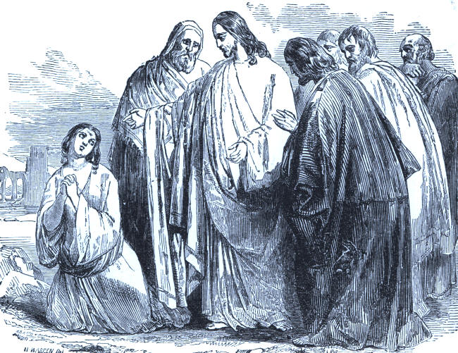
The Woman of Canaan

55
56
PATRIARCHS, KINGS, AND KINGDOMS.

David, whose undisputed authority, and admiration of the beautiful Bathsheba, deceived him, blinding his moral vision, thought all was safe. Death and royalty seemed to cover forever his sin.
But never was a man more mistaken. God sent Nathan, a fearless, faithful prophet, to rebuke him. So the seer went to him, inquiring what should be done with a man who had robbed a poor neighbor of his only and pet lamb. The king, who was really loyal to God, and just in his aims, indignantly said that the robber should die, and the lamb be restored. Then Nathan fixed his eye on the king, and, pointing to him, exclaimed courageously, "Thou art the man!"
David bowed his head and wept under the pointed reproof, and began to cry, "Deliver me from blood-guiltiness, oh, God, thou God of my salvation."

57
PATRIARCHS, KINGS, AND KINGDOMS.

What a fine example of faithful preaching, and of an honest hearer! This illustration of true penitence, which is given in the picture at the beginning of this history of the kings, suggests a good story of modern date. Jacob, an intelligent negro, was bribed and intoxicated to make him commit murder. He was convicted of the crime, and sent to the State prison for life. He could not read, but a bible was in his cell, and he learned so rapidly that soon he could pick out the words and get the meaning. He would run his finger over each letter of the fifty-first Psalm, especially the fourteenth verse, until he enamelled it with his touch. The bible is still kept by an excellent man, as a relic of prison-life. For Jacob was pardoned, went to the lovely town of C-, N. Y., and became an eminent Christian. His monument is one of the highest in the cemetery.
The Scriptures describe David as "a man after God's own heart." By this we are not to understand that David always acted rightly, or that God approved of all he did. Its meaning is, that, in his public capacity, as king of Israel, he acted in accordance with the true theory of the theocratical government; was always alive to his dependence on the Supreme King; took his own true place in the system, and aspired to no other; and conducted all his undertakings with reference to the Supreme Will. He constantly calls himself "the servant (or vassal) of Jehovah," and that, and no other, was the true place for the human king of Israel to fill. In thus limiting the description of David as "a man after God's own heart," it is not necessary for us to vindicate all his acts, or to uphold him as an immaculate character.

58

PATRIARCHS, KINGS, AND KINGDOMS.

But the same ardent temperament which sometimes betrayed his judgment in his public acts, led him into great errors and crimes. It also made him the first to discover his lapse, and the last to forgive himself.
Domestic afflictions humbled David, and persecution by enemies embittered his life. The kingly crown had its thorns. An only child died in infancy. Afterwards, his handsome and popular son, Absalom, was ambitious to get the throne of his father, and became the leader of a great revolt, in whose conflicts he was slain.
Solomon, another son, was the heir chosen by the Lord, to the crown of David. And when the monarch of Israel drew near the close of his stormy, yet splendid reign, he called the intellectual, comely, and dutiful boy to his bedside, to give him his last words of counsel and blessing.
This scene is depicted in the colored engraving. Among the paternal exhortations to the young prince was the following impressive address: "And thou, Solomon, my son, know thou the God of thy fathers, and serve him with a perfect heart, and with a willing mind; for the Lord searcheth all hearts, and understandeth all the imaginations of the thoughts. If thou seek him, he will be found of thee but if thou forsake him, he will cast thee off forever."

59
PATRIARCHS, KINGS, AND KINGDOMS.

Solomon, the second king of Israel, desired and sought, before riches and honors, wisdom from God, to govern well the people, and it was freely given.
Under his father's sceptre, Palestine was great in martial achievements, national wealth, and the fine arts; for the king was a poet and a musician. Solomon was a man of peace, and during his reign the kingdom reached its highest glory in oriental splendor and luxury. The temple he built was a monument of munificence, skill, and royal zeal for God's honor.
What a wonderful display of wisdom was that decision in the case of the two women, one of whom, in her sleep, lying upon her babe, had smothered it, and claimed the living child of the other, who lodged with her. He knew when he sent for the executioner, and told him to cut in two parts the live babe, giving to each a half, that the mother would be seen in the effect of the command to slay. And so it was. The faithless woman said let it be so; the loving, yearning mother exclaimed no, rather let the other have the child. Solomon wisely decided the matter, directing the attendants to give the unconscious object of controversy to her to whom it belonged.

60
PATRIARCHS, KINGS, AND KINGDOMS.

But this rich and popular monarch was led into sin by his unbounded prosperity, and indulging in forbidden pleasures. Afterwards he bitterly mourned over his folly and shameful weakness, in departing from the living God. This varied and, much of it, wasted life, led the king, in his sober years of declining age, to write the Book of Proverbs and Ecclesiastes, so full of the profoundest knowledge of mankind and wisest counsel. It is said that the Scotch are preeminently discerning and intelligent, because they are so familiar with the Scriptures, especially the proverbs of Solomon.
There were no more such monarchs in Israel, after David and Solomon, and the kingdom became divided and weakened, until the Jews were conquered and enslaved by their enemies. The expensive magnificence and luxury of Solomon's reign, and his departures from God into idolatrous worship, awakened the divine indignation.
A prophet was commissioned to tell the wise, yet foolish monarch that the kingdom should be rent in twain, and the grandeur of his empire depart before the revolt of the ten tribes from Judah, which had absorbed the small tribe of Benjamin. Solomon was about sixty years old when he died. He had ruled forty years, and was buried nine hundred and seventy-five years before the advent of Christ. Rehoboam, the son of Solomon, was made king over Judah, and Jereboam, an Ephraimite, became sovereign of the ten tribes, who were called Israel.

61
PATRIARCHS, KINGS, AND KINGDOMS.

How interesting and instructive the history of the Hebrews, at this period!
They got tired of the sovereignty of God, visible only in written rules of conduct, family government, and the prophet-judges, and desired to imitate their pagan neighbors in the pomp and power of royalty. Under their second monarch they quarrelled among themselves, engaged in civil strife, and became divided, rival kingdoms. During the five hundred years which followed, the successive kings of the two realms had, the most of them, brief sovereignty. Some of them were excellent kings, but the greater part were wicked and oppressive.
Pre-eminent in crime was Ahab, whose wife, Jezebel, was a fit companion.
Their names live in the world's history with a bad preeminence, like those of Herod, Nero, and similar rulers of ancient and modern times.
The corpse of a ruler, or of the humblest subject, was ordinarily wound in grave-clothes, and laid in a sepulchre. This, in the early ages, was a room hewn out of a rock, a cave, or a grave which had no mound, nor any other mark, excepting monumental stones, with no inscriptions.
The Arabian patriarch, Job, talked of kings and counsellors, who built for themselves "desolate places," which probably has reference to sepulchral monuments, cut out of the rock.

62
PATRIARCHS, KINGS, AND KINGDOMS.

The expression "a sepulchre on high," is an allusion to the custom anciently of placing the dead in tombs made in cliffs, sometimes hundreds of feet in height--a lofty, inaccessible resting-place for the body of a distinguished person.
Some nations of the heathen world have always burned their dead. In Japan, recently, an American traveller witnessed this singular disposal of the lifeless remains. A priest was placed in a sitting posture in his coffin, and a fire built behind it, consuming to ashes the body. These relics were carefully gathered up, and put in a safe and sacred place for all coming time.
It is a remarkable thing that the Bible does not record any solemn parade or imposing ceremonies over the burial of the Hebrew kings.
Of David it is written, he "slept with his fathers, and was buried in the city of David." The same simple and impressive mention is made of Solomon's death. Monarchs were only men--sinners to be saved by grace, if rescued at all from the power and ruin of sin. It is hoped and believed by Christian people that Solomon, in his declining years, reviewed prayerfully and penitently his career, and found peace with a pardoning God.

63
PATRIARCHS, KINGS, AND KINGDOMS.

The sepulchre of royalty in Jerusalem, is well worthy of a visit by travellers in the Holy Land. Some of the stone coffins lean against the solid walls, others lie in massive richness of sculpture on the floor.
The Jews called their burial places the house of the living, because of the expected resurrection--a beautiful sentiment, which rebukes the dismal thoughts and mourning of many Christian persons over the newly made graves of their departed friends.
The beautiful tomb in the "valley of Jehosaphat," is one of comparatively modern construction, but it shows the admiration felt by the Hebrews for Absalom, with all his waywardness.

64
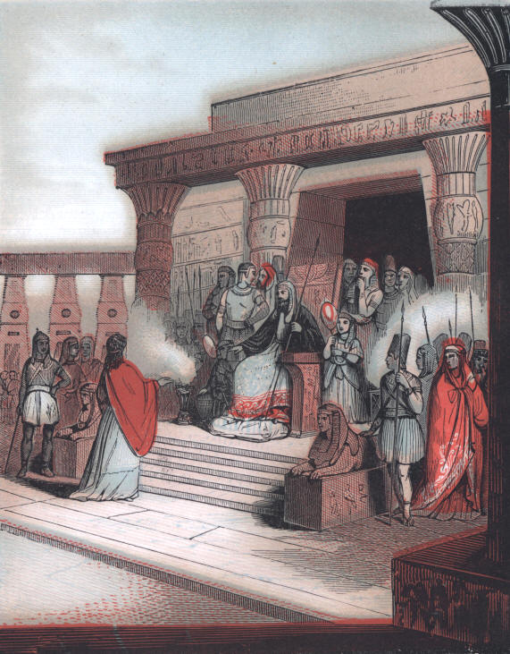
Joseph Elevated to Power by Pharaoh
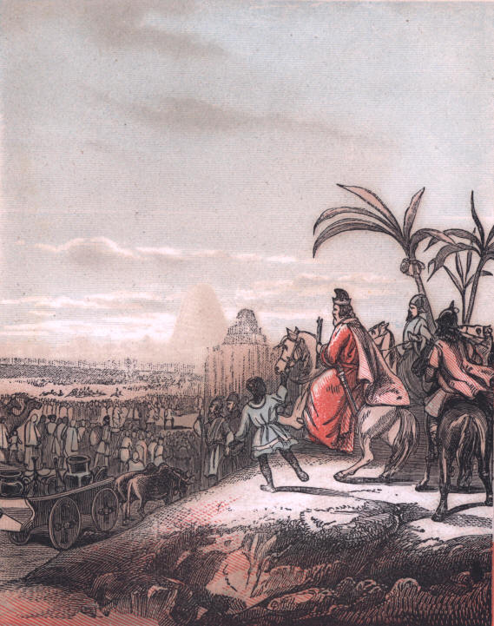
The Israelites Carried into Captivity.
THE BIBLE AND THE HOLY LAND.

PATRIARCHS, KINGS AND KINGDOMS.

PALESTINE UNDER PAGAN KINGS.

The picture which introduces these pages was drawn from a scene under the sceptre of the first monarch mentioned in the Bible.
A comparatively unimportant prince, the "King of Sodom," whose small and wicked realm Jehovah destroyed by fire and brimstone, is mentioned.
But the empire of the Pharaohs of Egypt, was large, rich, and magnificent. And it is a singular thing, that of this nation, and all others of antiquity, excepting what the Scriptures contain, the early history is little known. A great German historian, Dr. Von Rotteck, truly writes: "The principal trait that distinguishes the first period of the ancient world is its obscurity."
The general belief is, that the founders of Egypt went from Ethiopia, and the Ethiopians from East India or South Arabia.

65
PATRIARCHS, KINGS, AND KINGDOMS.

"Where did the Indiamen have their origin?" you may ask; but no man can certainly answer. That all races sprang from Adam we have no doubt, but the lines of descent and emigration the wisest student of the past cannot follow.
The living oracles, in brief statements, give us nearly all the reliable accounts we have of the early history of the "Land of the Nile," as Egypt was called. In them we learn that while the "chosen people of God," the only nation whose annals of growth in the number of its population and its civilization, has been handed down to us, was no more than a tribe of wandering shepherds under Abraham, Egypt was the home of art, and a garden of agricultural products.
And yet the very nomades, who roamed over the uncultivated plains, like the Aborigines of this new world, have preserved the best records of the early condition of that ancient and wonderful empire, whose origin is lost in the distance and darkness of Pagan antiquities.
It seems, from the tenth chapter of Genesis, that Egypt was settled by the descendants of Noah, through Ham, his second son.

66
PATRIARCHS, KINGS, AND KINGDOMS.

The next reference made to this remarkable country is in the twelfth chapter, where we are told of Abraham's visit there. Again, in the twenty-first chapter, is recorded the marriage of Ishmael to an Egyptian woman. In chapter twenty-ninth is related the story of Joseph's captivity and career in the capital of the Pagan monarchy. He was the twelfth son of Jacob, and one of Rachel's two boys--lovely in his youthful character, and the idol of his father. During a period of repose in sleep he had a singular dream. The first was, that while the brothers were all in the harvest-field at work his sheaf suddenly rose upright, and the sheaves of the eleven brethren stood up and bowed to his own. The intimation that he was to rule over them made them angry, and they hated him.
Soon after Joseph's sleep he was disturbed by another dream. The sun, moon, and eleven stars, rendered homage to him. The interpretation of this was the same as that of the other, with the addition of his father and mother, who also bowed before him.
It may seem strange that Joseph should relate any thing so complimentary to himself. But he evidently did it in no boasting mood. He simply narrated the extraordinary dreams, without the least idea of what was before him.
But God saw what he did hot know, that their jealousy and enmity would be overruled for the temporal salvation of the family and nation.
The venerable, thoughtful father, silently pondered over the singular experience of Joseph.

67
PATRIARCHS, KINGS, AND KINGDOMS.

The elder sons were shepherds, and fed their flocks in Shechem. How beautiful the ingenious, dutiful character of Joseph now appears! His father called him to go and find his brethren, to see how they were getting along. "Here am I," was his response. That is to say: "Although my brethren hate me, I am ready to serve you, and do any thing for them." He went to Shechem, but they had left; and the boy wandered about in the field looking for them. A citizen happened to see him, and was evidently interested in the beautiful stranger, bewildered and alone, and asked what he wanted. Joseph told him the truth of the case, when the man said that his brothers had taken their flocks to Dotham, a few miles distant.
He started for that place, and while a "great way off," they saw and knew him. The conspiracy was instantly formed to dispose of the "dreamer."
The first proposition was to kill him, but Reuben would not agree to the cruel suggestion. His plan was to cast the lad into a deep pit, till he could manage to get him back to his father. This less bloody way of disposing of Joseph was accepted, and when he came near they took off the "coat of many colors" the doting father had given him, and putting him in a pit without water which happened to be at hand, dipping it in blood to make his father think a beast killed him, they took it home. Scarcely was the interesting boy weeping in his prison before a caravan of Ishmaelites, and then of Midianites, came in sight.

68
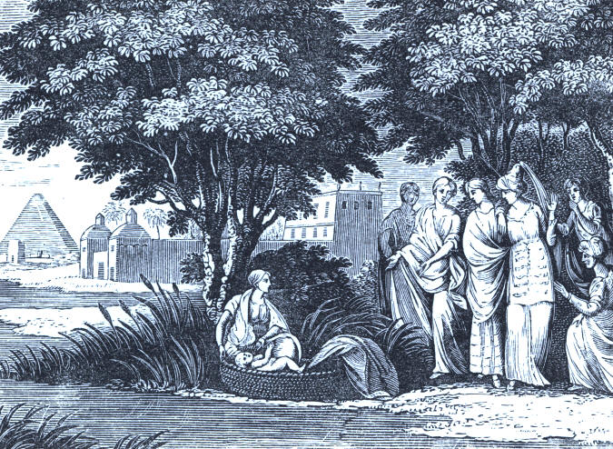
Moses Found in the Bulrushes.

69
70
PATRIARCHS, KINGS, AND KINGDOMS.

A new idea now flashed upon their minds. They could avoid the unpleasant consciousness of probable murder, and make something out of his sale as a slave to the wandering traders. A bargain was soon made, and young Joseph, casting backward a farewell look of sad reproach, was carried away, and sold by the Midianites to the Ishmaelites, of whom Potiphar, the captain of Pharaoh's guard, bought him for a servant. God blessed the youth, and he was soon made overseer of the officer's household. But Potiphar's wife was a vile woman, and because Joseph was nobly true to God and virtue, made a false report of him, and had him put in prison.
Egypt's monarch had wonderful dreams about a famine his astrologers could not explain; and a released prisoner, who had forgotten Joseph's kindness in explaining a dream of deliverance, advised the king to send for the Hebrew. The young man was taken to the palace, and gave a true interpretation of the dreams. Pharaoh was delighted; and from his dungeon Joseph went to the secret place of authority second to the king. Pharaoh said: "Only in the throne will I be greater than thou." He then put a ring on his finger, a gold chain on his neck, and arrayed him in fine apparel. The beautiful illustration sets this sudden and splendid promotion before us--the honor God put upon his youthful servant.

71
PATRIARCHS, KINGS, AND KINGDOMS.

Soon the predicted famine came, for which the gifted and prudent Joseph had made complete provision by storing up the abundant harvests. Among the sufferers from failing crops and pasturage, was the large family of Jacob--his sons and their households.
In their extremity they turned to Egypt. Joseph's influence was such that the patriarch's delegation found favor with the king. The prime-minister of Egypt knew his brethren, but they had forgotten him. So he managed to find out all about his father's house, and made his brothers bring dear Benjamin, when he wept aloud, and made himself known to them all. Pharaoh sent for the whole race, and soon the Hebrew caravan reached the fruitful land of Goshen, which was exactly suited to the life of shepherds. Here the strangers grew in numbers and wealth, until Joseph died, and the friendly monarch also. His successor cared neither for Joseph nor his countrymen. He was a tyrant, and enslaved the dwellers in Goshen. Centuries of captivity wore away, and God determined to deliver his people, and send them back again to Palestine.

72
PATRIARCHS, KINGS, AND KINGDOMS.

The scene displayed in this picture you will recognize at a glance. Moses, the Hebrew babe, afloat on the Nile, in a small boat made of bulrushes by his mother, because Pharaoh was slaying the children of her nation, to get rid of them.
Neither the haughty and cruel monarch, nor the mother, nor the little voyager, thought of Moses as the future deliverer of his countrymen from bondage--the great leader and lawgiver of Israel.
We have already had glimpses of the Hebrews in the wilderness, their progress and rulers in Palestine, after the moving multitude reached the "promised land."
The ages of changing sovereigns, and fortunes of crimes and discipline brought them at last to another mournful captivity.
About six hundred years before Christ, while that wicked Manassah was king in Palestine, the monarch of Assyria--a grand and powerful empire--invaded it, and took Jerusalem. Manassah was carried in chains to Babylon, the splendid Assyrian capital. His son, Amon, became the sovereign under the Assyrian conqueror, but was soon assassinated, and Josiah took the throne.
During his reign, the King of Egypt marched into Palestine and conquered it, killing Josiah, the king.

73
PATRIARCHS, KINGS, AND KINGDOMS.

A few years later, Nebuchadnezzar, the Babylonian monarch, besieged and took Jerusalem, the "City of David."
The massive walls of the cities of old was their chief protection. Those of Babylon, according to the old Roman historians, were marvelously great. Think of them rising three hundred and fifty feet, eighty-seven feet in thickness, and extending sixty miles around the city! One writer says, that two four-horse chariots could pass each other on the top. They were built of brick, cemented together with bitumen.
They had twenty gates made of solid brass, and were surmounted with two hundred and fifty towers.
The city had six hundred and seventy-six squares, each over two miles in circumference. The river Euphrates flowed through the entire extent, from north to south.
The hanging gardens, suspended from the walls, were gorgeous, and the public buildings rich and elegant.
Such was the home of the Hebrew exiles for seventy years or more.
Quintus Curtius, a Roman, has described the entrance of the great and victorious Alexander into Babylon, at a later period, who soon after died there of dissipation, while yet a young man. The pleasant sketch gives a vivid impression of the glory and pomp of this ancient capital of Babylon:

74
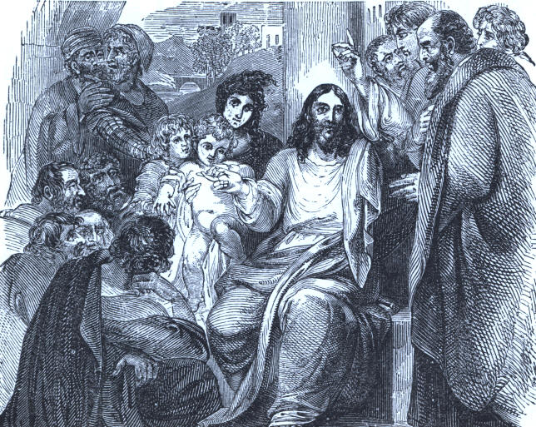
Christ Declaring Who is Greatest.

75
76
PATRIARCHS, KINGS, AND KINGDOMS.

"A great part of the inhabitants of Babylon stood on the walls, eager to catch a sight of their new monarch; many went forth to meet him. Among these Bagophanes, keeper of the citadel and of the royal treasure, strewed the entire way before the king with flowers and crowns; silver altars were also placed on both sides of the road, which were loaded not merely with frankincense, but all kinds of odoriferous herbs. He brought with him for Alexander gifts of various kinds, flocks of sheep and horses; lions, also, and panthers were carried before him in their dens. The magi came next, singing in their usual manner their ancient hymns. After them came the Chaldeans with their musical instruments, who are not only the prophets of the Babylonians, but their artists. The first are wont to sing the praises of the kings; the Chaldeans teach the motion of the stars, and the changes of the seasons. Then followed, last of all, the Babylonian knights, whose equipments, as well as that of their horses, showed the passion of the people for luxury. The king, Alexander, attended by armed men, having ordered the crowd of the townspeople to proceed in the rear of his infantry, entered the city in a chariot and repaired to the palace. The next day he carefully surveyed the household treasures of Darius, and all his money. For the rest, the beauty of the city and its age turned the eyes not only of the king, but of everyone in itself, and that with good reason."

77
PATRIARCHS, KINGS, AND KINGDOMS.

The kings and conquerors of old had no canals for boats, no railways, and not many good roads. Consequently, their invasions and various public enterprises were carried forward in a slow and toilsome manner. Heavy wagons and chariots, the latter sometimes armed with scythes or long blades for battle, were the best vehicles in use.
There were no monitors, nor fire-arms. Large swords, daggers, slings, the catapulta and battering-ram, were the principal weapons.
The last named instrument was a massive machine with a movable beam, crowned with a very hard end, often shaped like a ram's head, which could be thrown against a wall with tremendous force, beating it down.
The catapulta, which was placed upon city walls, was a great cross-bow for hurling arrows upon an enemy. In it was combined the bow and arrow, and the sling. The mammoth arrow was put in the groove, the twisted ropes were connected with levers, and the powerful recoil would send the strong and sharp arrow a great distance.
Some of the machines were large enough to discharge beams loaded with iron; and one kind, called the balista, would send great stones, crushing through the houses on which they fell.

78
PATRIARCHS, KINGS, AND KINGDOMS.

Among the spoil, taken by Nebuchadnezzar to Babylon, were the costly vessels of the temple; and he graced his train with members of the royal family and the principal nobles.
He placed Zedekiah on the throne of his Hebrew province, who soon after rebelled against him.
In consequence of this revolt, the Babylonian king invaded Judea with a great army, and, after taking most of the principal towns, sat down before Jerusalem. Early in the next year the Egyptians marched an army to the relief of their ally, but being intimidated by the alacrity with which the Babylonians raised the siege and advanced to give them battle, they returned home without risking an engagement. The return of the Chaldeans to the siege, destroyed all the hopes which the approach of the Egyptian succors had excited. The siege was now prosecuted with redoubled vigor; and at length Jerusalem was taken by storm at midnight, in the eleventh year of Zedekiah, and in the eighteenth month from the commencement of the siege. Dreadful was the carnage. The people, young and old, were slaughtered wherever they appeared; and even the temple was no refuge for them; the sacred courts streamed with blood. Zedekiah himself, with his family and some friends, contrived to escape from the city; but he was overtaken and captured in the plains of Jericho.

79
PATRIARCHS, KINGS, AND KINGDOMS.

He was sent in chains to Nebuchadnezzar, who had left the conclusion of the war to his generals, and was then at Riblah in Syria. After sternly reproving him for his ungrateful conduct, the conqueror ordered all the sons of Zedekiah to be slain before his eyes, and then his own eyes to be put out, thus making the slaughter of his children the last sight on which his tortured memory could dwell. He was afterward sent in fetters of brass to Babylon, where he remained until his death.
Nebuchadnezzar evidently felt that his purposes had not been fully executed by the army, or else he was urged by the Edomites and others to exceed his first intentions. He therefore sent Nebuzaradan, the captain of the guard, with a sufficient force to complete the desolation of Judah and Jerusalem. He burned the city and the temple to the ground; he collected and sent to Babylon all the gold and silver which former spoilers had left; and he transported all the people who had been left behind in Jehoiachin's captivity, save only the poor of the land, who were left to be vine-dressers and husbandmen. Four years after, Nebuzaradan again entered Judea, and gleaned a few more of the miserable inhabitants, whom he sent off to Babylon.

80
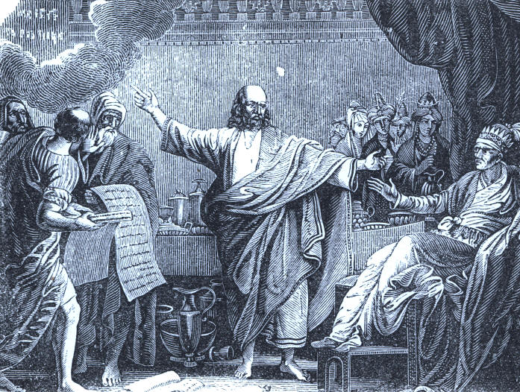
The Handwriting on the Wall.

81
82
PATRIARCHS, KINGS, AND KINGDOMS.

Thus was the land left desolate; and thus ended the kingdom of Judah and the reign of David's house, after it had endured four hundred and four years under twenty kings. It is remarkable that the King of Babylon made no attempt to colonize the country he had depopulated, as was done by the Assyrians in Israel; and thus, in the providence of God, the land was left vacant, to be re-occupied by the Jews after seventy years of captivity and punishment.
The grand and melancholy march into captivity is seen in the illustration of the artist.
What a vast and sad procession! The conquerors ride proudly on the high ground with the captive host in full view. The tower of Babel and the walls of their magnificent city are visible in the distance.
The exiles found in Babylon many of their countrymen, who had been carried there in previous conquests, and were useful, respectable citizens. Among these, there was a young man of splendid abilities and noble heart, named Daniel.
He was one of the youthful sons of high family, who were carried away as hostages for the fidelity of King Jehoiachin. He and some others were put under the chief eunuch, to be properly trained in the language and learning of the Chaldeans, to fit them for employments at the court. This training lasted three years, when they were examined in the presence of the king; and Daniel and three of his friends were found to have made far greater progress than any of those who had been educated with them. They were therefore enrolled among the magians or learned men.

83
PATRIARCHS, KINGS, AND KINGDOMS.

A few years after, Nebuchadnezzar was greatly troubled with a dream, which made a profound impression upon his mind; but the particulars of which quite passed from his memory when he awoke. Great importance was attached to dreams in those days, and men skilled in the sciences were supposed to be able to discover their meaning. Therefore, the king sent for his court magians, and required them not only to interpret the dream, but to discover the dream itself, which he had forgotten. This they declared to be impossible; on which the exasperated tyrant ordered all the magians to be massacred. Daniel and his friends, although not present, were included in such a sentence. On learning this, he begged a respite for the whole body, undertaking to find, through his God, the solution of the difficulty. The respite was granted; and at the earnest prayer of Daniel, God made the secret known to him. A colossal image which the king saw, with a head of gold, arms and breast of silver, belly and thighs of brass, legs of iron, and toes partly iron and partly clay, was struck down by a stone, which itself grew and filled the whole earth. This, in the interpretation of Daniel, figured forth "the things to come;" describing by characteristic symbols the succession of empires to the end of time; and it is wonderful to observe how precisely the greater part of what was then future has since been accomplished.

84
PATRIARCHS, KINGS. AND KINGDOMS

The king was not only satisfied but astonished; he was almost ready to pay divine honors to Daniel; and raised him at once to the eminent station of Archimagus, or chief of the magians, and governor of the metropolitan province of Babylon. His three friends, also, were at his request, promoted to places of trust and honor.
Not long after, Nebuchadnezzar set up a colossal image in the plains of Dura, and commanded that, when music sounded, everyone should worship it, on pain of death. He soon learned that this command was utterly neglected by Daniel's three friends, Shadrach, Meshach, and Abednego; and his rage grew so high, at the example of disobedience given by persons in their high station that he ordered them to be at once cast into "the burning furnace." The heat of the furnace was so great as to destroy the men who cast them in; but they themselves remained unhurt, and not even a hair of their heads was singed. They came forth when the king called them; and he was so much astonished and convinced by this prodigy, that he publicly acknowledged the greatness of the God whom they served.

85
PATRIARCHS, KINGS, AND KINGDOMS.

There appear to have been good and generous qualities in the character of Nebuchadnezzar; but the pride with which he contemplated the grandeur of his empire, and the magnificence of his undertakings, was most inordinate, and he required to be taught that "the Most High ruleth over all the kingdoms of the earth, and giveth them to whomsoever he will." He was warned of this in a dream, which was interpreted to him by Daniel; but, neglecting the warning, "his heart was changed from man's, and a beast's heart was given to him." He was afflicted with a madness which made him think himself a beast, and, acting as such, he remained constantly abroad in the fields, living upon wild herbs. In this debased and forlorn condition the mighty conqueror remained seven years, when he was restored to his reason and his throne, and one of his first acts was to issue a proclamation, humbly acknowledging the signs and wonders which the Most High God had wrought toward him, and declaring his conviction, that "those who walk in pride he is able to abase." He died soon after.
The next illustration is drawn from the interpretation of the dream in the royal palace. Conscious of Jehovah's favor and guidance, how courageously and grandly he stands before the monarch, and declares the whole counsel of God!
He thus became a prophet of the Most High, whose wonderful career afterwards, we shall again follow, when we come to the narratives of the seers.

86
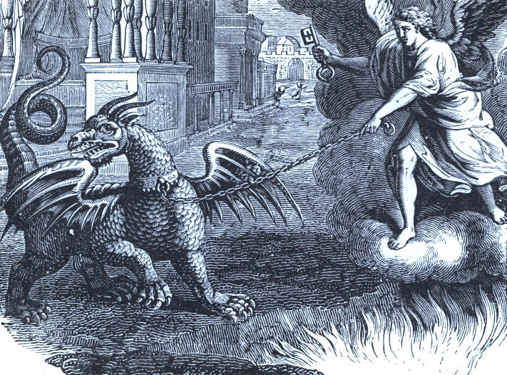
The vision of the Dragon Chained.

87
88
PATRIARCHS, KINGS, AND KINGDOMS.

The spirit alienation from God, and of depraved desires, which ruled the ancient pagan realms is set before us under various titles. Among them is that of the dragon, in the engraving; which the "king of kings" shall yet bind forever and imprison.
The fate of the proud kingdoms which ruled Palestine, teaches the world how little importance God attaches to human glory in his punishment of the wicked.
Egypt has scarcely more than its location and name left. Its pyramids, one of which it is estimated employed three hundred thousand men twenty years in building, stand in the desert places, solitary and pillaged sepulchres.
The temple of Karnak, on the east bank of the Nile, whose massive stone roof was supported by one hundred and thirty-four majestic columns, forty-three feet high, and ranged in sixteen rows; the whole structure twelve hundred feet in length, and covered with figures of gods and heroes; is one of the grandest works of time.
Should you visit the gorges of the Theban Mountains, your feet would stumble over the bones of departed generations. Princes, priests, and warriors, after reposing thousands of years in their deep seclusion, are dragged forth by poor peasants, and scattered around the doors of those cavern-like excavations in the everlasting hills.

89
PATRIARCHS, KINGS, AND KINGDOMS.

Lighting a torch or candle, you may wander along the rock-walled galleries several hundred feet into the heart of the summits, on each side of which are the apartments of death.
Inscriptions, three thousand years old, can be distinctly traced.
How little thought the Hebrews, while toiling under the shadow of palaces, or flying at night from the mighty realm of Egypt, of what we find to-day along the banks of the Nile!
The doom of Babylon, with that of the great invaders and conquerors of Palestine, is equally wonderful and instructive.
Probably no nation of antiquity was more distinguished for luxury and corrupt pleasures than this unrivalled city.
Its last king, Nabonnidus, reigned about one hundred years before Christ appeared; and in less than that time afterward, the city walls enclosed a hunting ground or park for the recreation of Persian monarchs. We cannot well imagine a more complete destruction than has overtaken the once rich and gay metropolis. The ruins are a number of mounds, formed of crumbled buildings, and strewn all over with pieces of brick, bitumen, and potter's vessels.
The Assyrian kings of western Asia, also invaded the Holy Land. They ruled a vast and powerful realm, whose principal city was Nineveh, to which Jonah was sent with a message from God.

90
PATRIARCHS, KINGS, AND KINGDOMS.

Sennacherib, the monarch who reigned seven hundred years before Christ, marched his armies against the cities of Judah and took them. Not satisfied with the terms of surrender he threatened further invasion.
At this crisis, in answer to prayer, Jehovah sent his angel to destroy the troops; and in one night the unseen messenger of destruction slew one hundred and eighty-five thousand men.
Of this miraculous defeat a gifted but irreligious and unhappy poet has sung:

And there lay the steed with his nostrils all wide,
But through them there rolled not the breath of his pride;
And the foam of his gasping lay white on the turf,
And cold as the spray of the rock-beaten surf.

And there lay the rider, distorted and pale,
With the dew on his brow and the rust on his mail;
And the tents were all silent, and the banners alone,
And the lances unlifted, the trumpets unblown.

91
PATRIARCHS, KINGS, AND KINGDOMS.

And the widows of Ashur are loud in their wail,
And the idols are broke in the temple of Baal;
And the might of the Gentiles, unsmote by the sword,
Hath melted like snow at the glance of the Lord.

Now the greater part of the country which once formed Assyria, is under the sway of the Turks.
Mosul, a missionary station of the American Board of Foreign Missions, is believed to mark the site of ancient Nineveh.
The original inhabitants of Assyria, in modern history, are the Kurds; a barbarous and warlike race. Some of these live in villages, and others roam over the country. They are said to resemble, in personal appearance, the Highlanders of Scotland.
But the most remarkable fact in regard to the population, is the ancient church of the Nestorians, among the mountains. This Christian people have for ages maintained their independence, defying the storms of revolution that have swept over all the country around their mountain home.
Dr. Grant, a missionary, thinks they are descendants of the "lost tribes of Israel." We recollect to have seen in the hands of the venerable missionary, Rev. Dr. Perkins, a copy of the Scriptures preserved for many hundred years by them: sometimes hidden away, to prevent its destruction by its enemies.

92
PATRIARCHS, KINGS, AND KINGDOMS.

Not long ago, one of the Nestorian bishops, Mar Yohanah, visited this country, and attracted much attention. A Jew-like, noble man personally, and a devout Christian.
But if you look on the map of Asia, you will see that Mosul and the Nestorian country is in Persia, and may wonder what it has to do with Assyria. In the conquests which weakened and divided the Assyrian empire, new kingdoms were formed; and while none can now accurately trace the boundaries of that great monarchy, we have the later outline of Persia. More will be said of this remarkable kingdom when we come to the story of Mordecai and Esther.
The thrones of these ancient monarchies were, at first, no more than an ornamented arm-chair, higher than ordinary seats, with a footstool for the royal feet. Then it was made in more massive form and richly carved, with steps ascending to it.
Some of the thrones were of ivory, adorned with gold; and it is recorded, that Archelaus addressed the multitude from a throne of solid gold--a magnificent fortune in itself. Thus gradually the throne became the highest symbol of power, and is often applied to Jehovah's sovereignty.

93
PATRIARCHS, KINGS, AND KINGDOMS.

He is represented as sitting upon a throne of light, and around him continually, attending angels, veiling their faces with their wings, and waiting to hear and obey his mandates; crying with their voices of celestial music, "Holy, holy, holy, Lord God Almighty, which was and is, and is to come!" A "crystal sea" is before this "White Throne" of a pure and just authority, and on it worships a resplendent host. Every sound and sight of glory and honor, that language can express, or the finest imagination picture, is ascribed to that eternal royalty.
Next to the throne, the crown became a sign of authority, although it was applied, at first, to other ornaments for the head, properly called coronets, garlands, tiaras, bands, mitres, etc.
The idea of a kingly crown was suggested by the diadem, which was a fillet--a mere band like that used to bind the long hair worn by the people--but richer and of a different color. It was natural and easy, with the increase of power and wealth, to make the crown a more costly and showy symbol of kingly sway.
David wore a crown of gold set with jewels, he took from the king of the Ammonites.
The more modern crowns of Asia, where all the kings reigned, of whom we have read in these pages, are of different shapes, and some of them very rich and expensive, ornamented with precious stones and plumes of the rarest kind.
Crowns are also often mentioned in the Bible as an emblem of power; and the Christian conqueror of his sins and the world, it is written, shall have "a crown of life."

94
PATRIARCHS, KINGS, AND KINGDOMS.

The sceptre was the third token of sovereignty. The word originally signified a staff of wood of the length of a man's height. Later, it was smaller in form, and often plated with gold, and enriched with various decorations. Inclining, or holding out the sceptre was a mark of royal favor; and kissing it by another, a sign of submission.
Jehovah's rule is mentioned frequently in the inspired record, under this figure. "His sceptre is a right sceptre," in one of the declarations, which even the wicked and most wretched on account of transgression, dare not deny.
Under its wide dominion are Heaven, Earth, and Hell, not only, but a universe whose boundaries neither man nor angel can ever reach.
"He is God over all, and blessed forever!"
How amazing the truth of such a king and kingdom! Under the unsleeping eye of the Sovereign, the planet wheels on its axis with startling velocity, and the insect creeps on the grain of sand. A Russian poet beautifully sung:

Oh, thou Eternal One! whose presence bright,
All space doth occupy, all motion guide!
Unchanged through time's all devastating flight,
Thou only God, there is no God beside!

95
PATRIARCHS, KINGS, AND KINGDOMS.

Being above all beings! mighty one,
Whom none can comprehend, and none explore!
Who filled existence with thyself alone;
Embracing all, supporting, ruling o'er!
Being, whom we call God, and know no more!

Thou art! directing, guiding all. Thou art!
Direct my understanding then to thee;
Control my spirit, guide my wandering heart,
Though but an atom 'mid immensity.
Still I am something fashioned by thy hand!
I hold a middle rank 'twixt heaven and earth,
On the last verge of mortal being stand,
Close to the realms where angels have their birth,
Just on the boundaries of the spirit land.

Oh, thoughts ineffable! Oh, visions blest!
Though worthless our conceptions all of thee;
Yet shall thy shadowed image fill our breasts,
And waft its homage to thy Deity.
God! thus alone my lowly thoughts can soar;
Thus seek thy presence--Being wise and good!
'Midst thy best works admire, obey, adore!
And when the tongue is eloquent no more,
The soul shall speak in tears of gratitude.

96
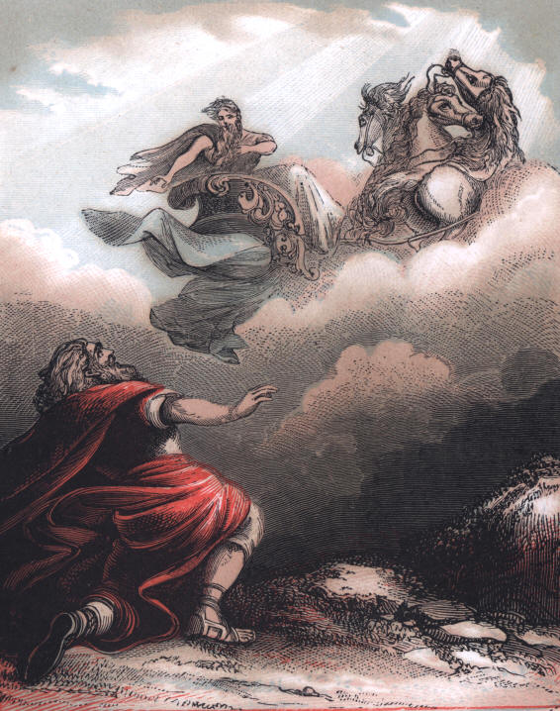
Ascent of Elijah.
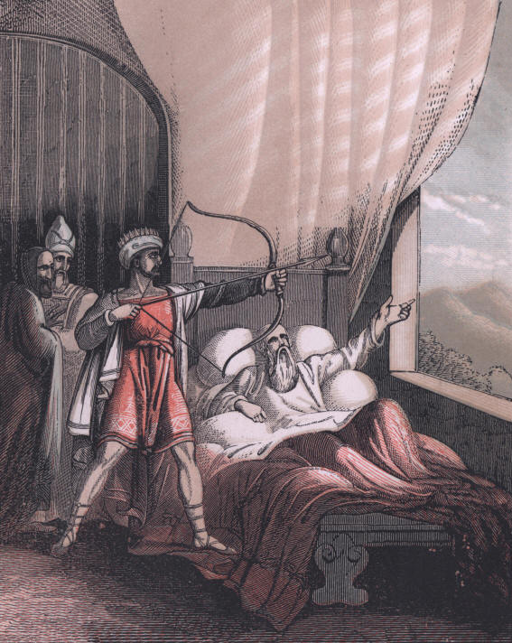
Elisha on His Death Bed.
THE BIBLE AND THE HOLY LAND

PATRIARCHS, KINGS, AND KINGDOMS.

HEBREW CAPTIVES; OR, MORDECAI AND ESTHER.

The next pictured scene is in the Court of Persia. It will not be forgotten that Daniel was a captive in Babylon under the last kings, and probably died there after the city was taken by Cyrus. Of this great man's history as a captive we shall learn more when we go with the prophets of God in their peculiar mission.
Nabonadrius, the son of Darius, usurped the throne after his father's death; and after reigning several years, Cyrus, a nephew of Darius, a Persian general who was occupied in foreign wars, turned his attention to the reigning monarch.
He marched against the gorgeous metropolis, and besieged it for two years in vain. He at last thought of a stratagem which displayed his genius and boldness of action. He determined to turn the channel of the Euphrates, which went through the whole length of the city, from the walls where it entered, and get into the capital through the dry channel, under the massive pile which no battering rams could crumble. He succeeded in making a new bed for the stream, and his troops went into Babylon over a path washed for ages by the waters of the Euphrates.

97
PATRIARCHS, KINGS, AND KINGDOMS.

Media, a word some suppose to be derived from Madai, the son of Japheth, was the name of a region adjacent to ancient Assyria, inhabited by warlike hordes for centuries. The little that is said of these people in the Bible, is in connection with the Persians. Both seemed to have become one nation; first the Medes gaining the ascendancy, and then the Persians. But the darkness which rests upon the origin of the Asiatic lands bewilders the most careful historian.
The conspicuous appearance of the Medes and Persians begins with Cyrus the Great, the conqueror of Babylon, a remarkable monarch in power, glory, and character.
The picture of the magi who journeyed from the east to find the infant Messiah, presents a peculiar view of the Persians and Arabians. Among these gentile nations were men of great attainments in whatever of philosophy and astrology there was in the world. The Ethiopian race is represented, and it may have been that dark faces were over the wonderful child. Color was evidently then no honor or disgrace; the man was the object of regard or scorn. More will be said of these wonderful travellers in the more appropriate place in the annals of Palestine.

98
PATRIARCHS, KINGS, AND KINGDOMS.

Cyrus the first, and noble Persian monarch, was kindly disposed toward the captive Jews, and Daniel had great influence over him. In the very year of his conquest he issued a decree, in which, after acknowledging the supremacy of the Lord, and that to him he owed all kingdoms, he gave full permission to the Jews in any part of his dominions, to return to their own land and to rebuild the city and temple of Jerusalem. No sooner were the favorable dispositions of the king thus made known, than the members of the latter captivity--those of the tribes of Judah, Benjamin, and Levi--repaired in large numbers to Babylon from their different places of residence; some to make preparations for their journey; and others, who had no intention to return themselves, to assist those who had. Most of the existing race had been born in Babylonia, and in the course of years families had established themselves in the country, and formed connections, and gathered around them comforts which were not easily abandoned. Only a minority availed themselves of the decree in their favor; the most of the people choosing to remain in the land of their exile; and it has always been the opinion of the Jews that the more illustrious portion of their nation remained in Babylonia.

99
PATRIARCHS, KINGS, AND KINGDOMS.

The first return caravan was organized and directed by Zerubbabel, the grandson of king Jehoiachim, and by Jeshua, a grandson of the last high-priest Jozadak. The number of persons who joined them was about fifty thousand, including above seven thousand male and female servants. Before they departed, Cyrus restored to them the more valuable of the sacred utensils, which had been removed by Nebuchadnezzar, and preserved by his successors, and which were now to be again employed in the service of the sanctuary. Zerubbabel was also entrusted with large contributions toward the expense of rebuilding the temple, from the Jews who chose to remain behind. The beasts of burden in this caravan exceeded eight thousand. In the book of Ezra, the names of the families which returned to this first colony, and in those which followed, are carefully given.
The incidents of the journey are not related. On reaching Palestine the caravan repaired at once to Jerusalem, which they found utterly ruined and desolate. Before they separated to seek habitations for themselves, they raised a large sum by voluntary contributions toward the rebuilding of the temple. Then they employed themselves in securing dwellings and necessaries for their families; and at the ensuing Feast of Tabernacles again repaired to Jerusalem, where sacrifices were offered on an altar erected upon the ruins of the temple. After this the people applied themselves zealously to the necessary preparation for the restoration of that edifice.

100
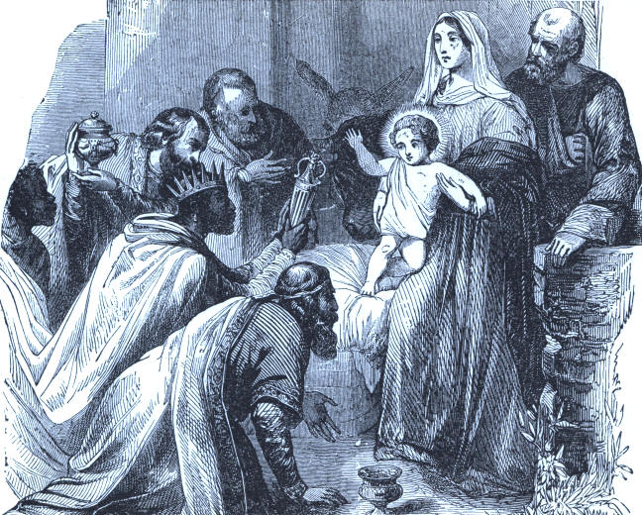
The Magi offering Presents.

101
102
PATRIARCHS, KINGS, AND KINGDOMS.

In a year from the departure from Babylon, the preparations were sufficiently advanced to allow the work to be commenced; and, accordingly, the foundations of the second temple were then laid with great rejoicings and songs of thanksgiving. While the work proceeded, the Samaritans manifested a desire to assist in the work, and to claim a community of worship in the new temple. This was declined by the Jews on the ground that the decree of the Persian king extended only to the race of Israel.
Being thus frustrated in their design, the Samaritans employed every means they could devise to thwart the undertaking. Their origin appears to have given them considerable influence at the Persian court; and although they could not act openly against the plain decree of Cyrus, an unscrupulous use of their money and influence among the officers of the government enabled them to raise such obstructions, that the people were much discouraged, and the work proceeded but languidly, and at length was suspended altogether. From this lethargy they were roused by the exhortations and reproaches of the prophet Haggai; and the building was resumed with fresh zeal.
The new temple was dedicated with great solemnity and joy. The Jews were allowed the free exercise of their religion and laws, and the government was directed by a governor of their own nation, or by the high-priest, when there was no other governor.

103
PATRIARCHS, KINGS, AND KINGDOMS

There was, in fact, a distinct commonwealth, with its own peculiar institutions; and, although responsible to the Persian king, and to his deputy the governor-general of Syria, it was more secure under the protection of the monarch than it would have been in complete independence. The dreadful lesson taught by the desolation of the land, the destruction of the temple, and the captivity of the people, had effectually cured the Jews of that tendency to idolatry which had been their ruin. But, as time went on, the distortion of character which had been restrained in one direction broke forth in another; and although they no longer went formally astray from a religion which did not suit their depravity, they, by many vain and mischievous fancies, fabricated a religion suited to their dispositions out of the ritual to which they adhered.
Early in the reign of Artaxerxes, son of the mighty Xerxes, the Hebrews went to work on the beloved city with a regular plan of its rebuilding, including an encircling wall.
This king had learned by reading and traditions, the veneration which his most distinguished predecessors had shown for the God of Israel; and about seven years after he ascended the throne, he commissioned Ezra, the priest and scribe, to take charge of the religious service at Jerusalem. And he was, in reality, the governor or viceroy under the monarch.

104
PATRIARCHS, KINGS, AND KINGDOMS.

Those of the Hebrews who desired to do so, were invited to return with him, and others who remained, were to pay contributions for the use of the temple.
To this fund the king himself and his council contributed large sums of money; and the ministers of the royal realms west of the Euphrates, were enjoined to furnish Ezra with silver, wheat, wine, oil, and salt, that the sacrifices and offerings of the temple should be constantly kept up; all of which is said to have been done in order to avert from the king and his sons, the wrath of the God of the Hebrews, who was held in much honor at the Persian court.
An exemption from all taxes was also promised to persons engaged in the service of the temple; but this boon did not induce any of the Levitical tribe to join the caravan which assembled on the banks of the river Ahava, in Babylonia: and it was with some difficulty that Ezra at last induced some of the priestly families to go with him. The whole caravan was composed of one thousand seven hundred and fifty-four adult males--making, with wives and children, about six thousand persons. As a party thus composed had little military strength, and as the journey across the desert was then, as it always has been, dangerous from the Arab tribes by which it is infested, they felt considerable anxiety on this account.

105
PATRIARCHS, KINGS, AND KINGDOMS.

But Ezra, from having said much to the king of the power of God to protect and deliver those that trusted in him, felt disinclined to apply for a guard of soldiers; and thought it better that the party should, in a solemn act of fasting and prayer, cast themselves upon the care of their God. Their confidence was rewarded by the perfect safety with which their journey was accomplished. In four months they arrived at Jerusalem.
While Ezra, with his sealed commission from Artaxerxes, was urging on the noble work at Jerusalem, an unexpected danger to his people in Babylon and its provinces arose--a sudden and fearful crisis in destiny.
Among the captives there was Esther, a Hebrew maiden. The Persian king, to commemorate his victorious and prosperous reign, extending from Judea to Ethiopia, and embracing a hundred and twenty-seven provinces, made a magnificent feast, which continued six months. This was to display his power and wealth, before the nobility of his realm, and representatives from the conquered provinces of his spreading empire. At the expiration of this brilliant entertainment, he gave the common people, without distinction, a feast of seven days in the court of his palace.

106
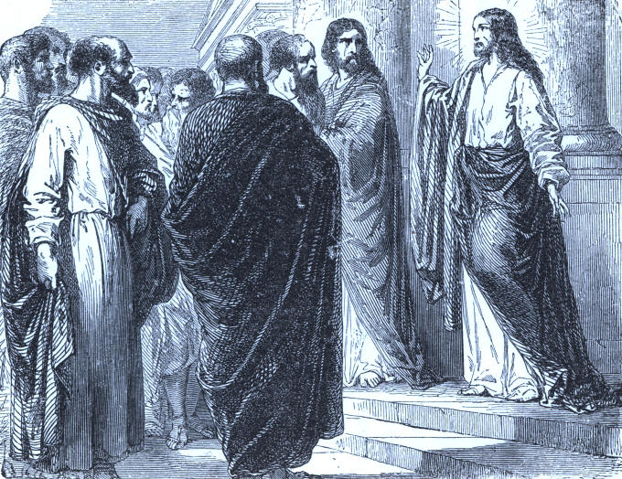
Our Saviour Teaching in the Temple.

107
108
PATRIARCHS, KINGS, AND KINGDOMS.

The rich canopy and gorgeous curtains, with their fastenings--the tall columns, the golden couches, and tesselated floors--are described as "white, green, and blue hangings, fastened with cords of fine linen and purple to silver rings, and pillars of marble: the beds were of gold and silver, upon a pavement of red, and blue, and black, and white marble."
Of this grandeur, in the ashes strewn by wasting ages, are imposing remains. Modern travellers pause before "the vast, solitary, mutilated columns of the magnificent colonnades," where youth and beauty graced the harems of Persian monarchs.
Upon this occasion, the queen had a private pavilion for her female guests. But during the successive days of dissipation, the mirth waxed loud in the apartments of the king. The flashing goblet circulated freely, and his brain became wild with "wine and wassail." As the crowning display of his glory, Vashti, in her jeweled robes and diadem, must grace the banquet. The command was issued, and the messenger sent. This mandate, requiring what at any time was contrary to custom, the appearance of a woman, unveiled, in an assemblage of men, now when revelry and riot betrayed the royal intoxication, overwhelmed the queen with surprise. A thousand wondering and beaming eyes were upon her during the brief pause before answering the summons.

109
PATRIARCHS, KINGS, AND KINGDOMS.

Her proud refusal to appear, roused the fury of Ahashuerus, already mad with excitement. It would not answer to pass by the indignity, for a hundred and twenty-seven provinces were represented at his court, and the news of his sullied honor would reach every dwelling in his realm, and curl the lip of the serf with scorn. The nobles fanned the flame of his indignation. Unless a withering rebuke were administered, their authority as husbands would be gone, and the caprice of woman make every family a scene of daily revolution.
Vashti was divorced--and to provide for the emergency, his courtiers suggested that he should collect in his harem all the beautiful virgins of the land, and choose him a wife. Among these was Hadassah, the adopted daughter of Mordecai. He urged her to enter her name among the rivals for kingly favor. It was not ambition merely that moved Mordecai. He had been meditating upon the unfolding providence of God toward his scattered nation, and felt that there was deeper meaning in passing events than the pleasures and anger of his sovereign. Arrayed richly as circumstances would permit, the beautiful Jewess, concealing her lineage, joined the youthful procession that entered the audience chamber of Ahashuerus, where he sat in state, to look along the rank of female beauty, floating like a vision before him.

110
PATRIARCHS, KINGS, AND KINGDOMS

The character of Esther is here exhibited at the outset; for when she went into the presence of the king, for his inspection, instead of asking for gifts as allowed by him, and as the others did, she took only what the chamberlain gave her. Of exquisite form and faultless features, her rare beauty at once captivated the king, and he made her his wife.
Mordecai was a man of a noble heart, grand intellect, and unwavering integrity; there was nevertheless an air of severity about him--a haughty, unbending spirit; which with his high sense of honor and scorn of meanness would prompt him to lead an isolated life. We have sometimes thought that even he had not been able to resist the fascinations of his young and beautiful cousin, and that the effort to conceal his feelings had given a greater severity to his manner than he naturally possessed. Too noble, however, to sacrifice such a beautiful being by uniting her fate with his own, when a throne was offered her; or perceiving that the lovely and gentle being he had seen ripen into faultless womanhood could never return his love--indeed, could cherish no feeling but that of a fond daughter, he crushed by his strong will his fruitless passion. In no other way can I account for the life he led, lingering forever around the palace gates, where now and then he might get a glimpse of her who had been the light of his soul, the one bright bird which had cheered his exile's home.

111
PATRIARCHS, KINGS, AND KINGDOMS.

That home he wished no longer to see, and day after day he took his old station at the gates of Shushan, and looked upon the magnificent walls that divided him from all that had made life desirable. It seems also as if some latent fear that Haman, the favorite of the king--younger than his master, and of vast ambition, might attempt to exert too great an influence over his cousin, must have prompted him to treat the latter with disrespect, and refuse him that homage which was his due. No reason is given for the hostility he manifested, and which he must have known would end in his own destruction.
Whenever Haman, with his retinue, came from the palace, all paid him the reverence due to the king's favorite but Mordecai, who sat like a statue, not even turning his head to notice him. He acted like one tired of life, and at length succeeded in arousing the deadly hostility of the haughty minister. The latter, however, scorning to be revenged on one man, and he a person of low birth, persuaded the king to decree the slaughter of all the Jews in his realm. The news fell like a thunderbolt on Mordecai. Sullen, proud, and indifferent to his own fate, he had defied his enemy to do his worst; but such a savage vengeance had never entered his mind, It was too late, however, to regret his behavior. Right or wrong, he had been the cause of the bloody sentence, and he roused himself to avert the awful catastrophe.

112
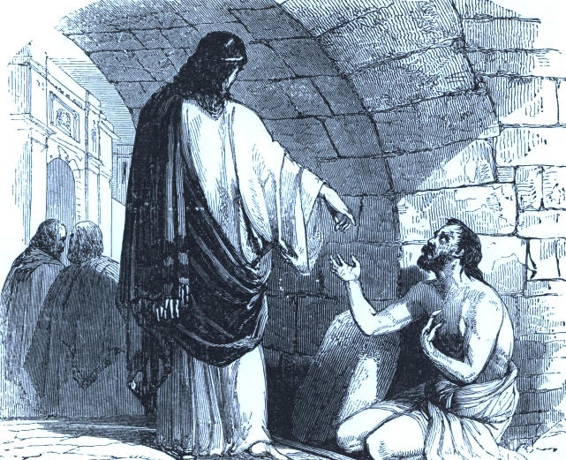
Humility Exemplified--Giving Alms in Secret.

113
114
PATRIARCHS, KINGS, AND KINGDOMS.

With rent garments, and sackcloth on his head, he travelled the city with a loud and bitter cry, and his voice rang even over the walls of the palace, in tones that startled its slumbering inmates. .
It was told Esther, and she ordered garments to be given him, but he refused to receive them, and sent back a copy of the king's decree, respecting the massacre of the Jews, and bade her go in and supplicate him to remit the sentence. She replied that it was certain death to enter the king's presence unbidden, unless he chose to hold out his sceptre; and that for a whole month he had not requested to see her. Her stern cousin, however, unmoved by the danger to herself, and thinking only of his people, replied haughtily that she might do as she chose; if she preferred to save herself, delivery would come to the Jews from some other quarter, but she should die.
From this moment the character of Esther unfolds itself. It was only a passing weakness that prompted her to put in a word for her own life, and she at once rose to the dignity of a martyr. The blood of the proud and heroic Mordecai flowed in her veins, and she said: "Go, tell my cousin to assemble all the Jews in Shushan, and fast three days and three nights, neither eating nor drinking; I and my maidens will do the same, and on the third day I will go before the king, and if I perish, I perish!" Noble and brave heart! death--a violent death--is terrible; but thou art equal.

115
PATRIARCHS, KINGS, AND KINGDOMS.

There, in that magnificent apartment, filled with perfume, and where the softened light, stealing through the gorgeous windows by day, and shed from golden lamps by night on marble columns and golden- colored couches, makes a scene of enchantment, behold Esther, with her royal apparel thrown aside, kneeling on the tesselated floor. There she has been two days and nights, neither eating nor drinking, while hunger, and thirst, and mental agony have made fearful inroads on her beauty. Her cheeks are sunken and haggard--her large and lustrous eyes dim with weeping, and her lips parched and dry, yet ever moving in inward prayer. Mental and physical suffering have crushed her young heart within her, and now the hour of her destiny is approaching. Ah! who can tell the desperate effort it required to prepare for that terrible interview. Never before did it become her to look so fascinating as then; and removing with tremulous anxiety the traces of her suffering, she decked herself in the most becoming apparel she could select. Her long black tresses were never before so carefully braided over her polished forehead, and never before did she put forth such an effort to enhance every charm, and make her beauty irresistible to the king.

116
PATRIARCHS, KINGS, AND KINGDOMS.

At length, fully arrayed and looking more like a goddess dropped from the clouds, than a being of clay, she stole tremblingly toward the king's chamber. Stopping a moment at the threshold to swallow down the choking sensation that almost suffocated her, and to gather her failing strength, she passed slowly into the room, while her maidens stood breathless without, listening, and waiting with the intensest anxiety the issue. Hearing a slight rustling, the king, with a sudden frown, looked up to see who was so sick of life as to dare to come unbidden in his presence, and lo! Esther stood speechless before him. Her long fastings and watchings had taken the color from her cheeks, but had given a greater transparency in its place, and as she stood, half shrinking, with the shadow of profound melancholy on her pallid, but indescribably beautiful countenance, her pencilled brow slightly contracted in the intensity of her excitement, her long lashes dripping in tears, and lips trembling with agitation; she was, though silent, in herself an appeal that a heart of stone could not resist. The monarch gazed long and silently on her, as she stood waiting her doom. Shall she die? No; the golden sceptre slowly rises and points to her. The beautiful intruder is welcome, and sinks like a snow wreath at his feet.

117
PATRIARCHS, KINGS, AND KINGDOMS.

Never before did the monarch gaze on such transcendent loveliness; and spell-bound and conquered by it, he said, in a gentle voice: "What wilt thou, Queen Esther? What is thy request? It shall be granted thee, even to the half of my kingdom!"
Woman-like, she did not wish to risk the influence she had suddenly gained, by asking the destruction of his favorite, and the reversion of his unalterable decree, and so she prayed only that he and Haman might banquet with her the next day. She had thrown her fetters over him, and was determined to fascinate him still more deeply before she ventured on so bold a movement. At the banquet he again asked her what she desired, for he well knew that it was no ordinary matter that had induced her to peril her life by entering unbidden his presence. She invited him to a second feast, and at that to a third. But the night previous to the last, the king could not sleep, and after tossing awhile on his troubled couch, he called for the record of the court, and there found that Mordecai had a short time before informed him through the queen, of an attempt to assassinate him, and no reward been bestowed. The next day, therefore, he made Haman perform the humiliating office of leading his enemy in triumph through the streets, proclaiming before him: "This is the man whom the king delighteth to honor." As he passed by the gallows he had the day before erected for that very man, a shudder crept through his frame, and the first omen of coming evil cast its shadow on his spirit.

118
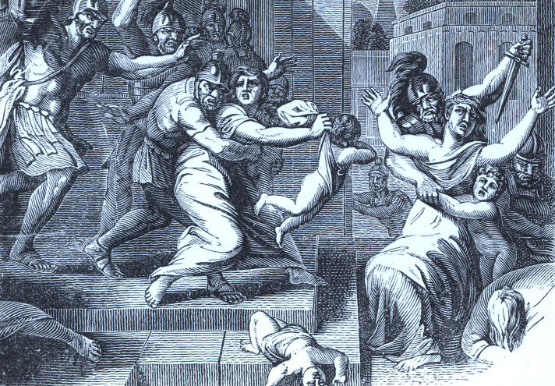
Herod's Cruel Massacre.

119
120
PATRIARCHS, KINGS, AND KINGDOMS.

The way was now clear to Esther, and so the next day, at the banquet, as the king repeated his former offer, she, reclining on the couch, her chiseled form and ravishing beauty inflaming the ardent monarch with love and desire, said in pleading accents: "I ask, O king, for my life, and that of my people. If we had all been sold as bondmen and bondwomen, I had held my tongue, great as the evil would have been to thee." The king started, as if stung by an adder, and with a brow dark as wrath, and a voice that sent Haman to his feet, exclaimed: "Thy life! my queen? Who is he? where is he that dare even harbor such a thought in his heart? He who strikes at thy life, radiant creature, plants his presumptuous blow on his monarch's bosom." "That man," said the lovely pleader, "is the wicked Haman." Darting one look of vengeance on the petrified favorite, he strode forth into the garden to control his boiling passions. Haman saw at once that his only hope now was in moving the sympathies of the queen in his behalf; and approaching her, he began to plead most piteously for his life. In his agony he fell on the couch where she lay, and while in this position the king returned. "What!" he exclaimed, "will he violate the queen here in my own palace!"

121
PATRIARCHS, KINGS, AND KINGDOMS.

Nothing more was said; no order was given. The look and voice of terrible wrath in which this was said, were sufficient. The attendants simply spread a cloth over Haman's face, and not a word was spoken. Those who came in, when they saw the covered countenance, knew the import. It was the sentence of death. The vaulting favorite himself dare not remove it--he must die, and the quicker the agony is over, the better. In a few hours he was swinging on the gallows he had erected for Mordecai.
After this, the queen's power was supreme--every thing she asked was granted. To please her he let his palace flow in the blood of five hundred of his subjects, whom the Jews slew in self-defence. For her he hung Haman's ten sons on the gallows where the father had suffered before them. For her he made Mordecai prime minister, and lavished boundless favors on the hitherto oppressed Hebrews. And right worthy was she of all he did for her. Lovely in character as she was in person, her sudden elevation did not make her vain, nor her power haughty. The same gentle, pure, and noble creature when queen, as when living in the lowly habitation of her cousin, generous, disinterested, and ready to die for others, she is one of the loveliest characters furnished in the annals of history.

122
PATRIARCHS, KINGS, AND KINGDOMS.

It is a little singular that the words, God or Providence, are not mentioned in the whole book of Esther. The writer seems studiously to have avoided any reference to them, as if he did not wish to recognize the interposition of Heaven in any of the events that transpired; while his narrative is evidently designed to teach nothing else. The hand of Providence is everywhere seen managing the whole scheme.
But the greatest acts of Providence awaken the least attention among blind, mortal men. We are startled when some great occurrence meets us, but overlook the vast effects which follow causes that attracted no eye but God's. We see the flying timbers and flaming ruins of a conflagration, and forget that a concealed spark did it all.
A noble mind and body are wrecked, and many weep; yet how few think that the blast of moral ruin which stranded the life-bark, was once the quiet breath of a mother's unholy influence leading the boy astray.
So the splendid career of a hero and patriot, like Mordecai, Moses, or Washington, is less glorious than the simple decision made amid the conflicting emotions of youthful aspiration to honor God and serve a struggling country.

123
PATRIARCHS, KINGS, AND KINGDOMS.

Jehovah illustrates this principle in all his administration. What to Elijah on the solemn mount was the sweep of the hurricane, rending the cliffs and tossing rocks like withered leaves in air--the thunder of the earthquake's march--the blinding glow of the mantling flame--compared to the "still small voice" that thrilled on his ear, so full of God! It is not strange that there is to be a reckoning for "idle words" even, for they have shaken the world, and their echo will never die away.
Their mutual love and devout character, remind us of the affectionate fidelity to each other and to God, of Ruth the Moabitess, and her Hebrew mother-in-law Naomi, who lived in the time of the Judges.
Naomi's family were self-exiled on account of famine in Palestine. Ruth had married a man of Moab; but he and her father-in-law died. A sister whose husband was brother to her own, was also a widow; and when Naomi determined to return to her native land, at her request, Orphah sought her people and friends.
Ruth would not leave the pilgrim to the Holy Land. Embracing Naomi, she said: "Entreat me not to leave thee, for where thou goest I will go, and where thou lodgest, I will lodge: thy people shall be mine, and thy God my God: where thou diest I will die, and there will I be buried: naught but death shall part us."
Beautiful and brave heart! home, and friends, and wealth, nay, the gods she had been taught to worship, were all forgotten in the warmth of her affection.

124
PATRIARCHS, KINGS, AND KINGDOMS.

Tearful yet firm, "Entreat me not to leave thee," she said. "I care not for the future; I can bear the worst; and when thou art taken from me, I will linger around thy grave till I die, and then the stranger shall lay me by thy side!" What could Naomi do but fold the beautiful being to her bosom and be silent, except as tears gave utterance to her emotions. Such a heart outweighs the treasures of the world, and such absorbing love, truth, and virtue, make all the accomplishments of life appear worthless in comparison.
God blessed their devotion to him and each other, giving his special tokens of favor to the young heroine from Moab. Upon reaching Bethlehem, she went into the fields of a kinsman of her mother-in-law, Boaz, a wealthy citizen, to glean after the reapers. He inquired after her, became interested in her, and, remembering his obligations on account of their relationship, married her. An honorable portion and plenty crowned the homeless wanderings of Ruth and Naomi, as they did the captivity of Mordecai and Esther.
About two hundred years after the death of the latter, the Hebrew Scriptures were translated into Greek by the order of Ptolemy Philadelphus, the Egyptian sovereign of Palestine, making the famous Septuagint--the name probably referring to seventy-two persons engaged on the work.

125
PATRIARCHS, KINGS, AND KINGDOMS.

A little over two centuries passed, and the Roman armies began their conquests in Asia. Less than a score of years later Herod the Great governed Judea, under the Roman emperor. This Herod, whose reign closed the ancient annals of Palestine, was an Edomite--a cruel and ambitious man.
Less than thirty years passed, and one of the darkest, bloodiest acts of any sovereign since time began, disgraced the reign of Herod.
Jerusalem was astonished by the arrival of three sages from the distant east, inquiring for a new-born king, saying that they had seen "his star," and had come to offer him their gifts and homage. They found him in the manger at Bethlehem: and then repaired to their own country without returning to Jerusalem, as Herod had desired. The jealousy of that tyrant had been awakened by their inquiry for the "King of the Jews;" and as their neglect to return prevented him from distinguishing the object of their homage, he had the inconceivable barbarity to order that all the children in Bethlehem under two years of age should be put to death, trusting that the intended victim would fall in the general slaughter; but Joseph had previously been warned in a dream to take his wife and the infant to the land of Egypt, whence they did not return till after the death of Herod.
That event was not long delayed. In the sixty-ninth year of his age. Herod fell ill of the disease which occasioned his death.

126
PATRIARCHS, KINGS, AND KINGDOMS.

That disease was in his bowels, and not only put him to the most cruel tortures, but rendered him altogether loathsome to himself and others. The natural ferocity of his temper could not be tamed by such experience. Knowing that the nation would little regret his death, he ordered the persons of chief note to be confined in a tower, and all of them to be slain when his own death took place, that there might be cause for weeping in Jerusalem. This savage order was not executed. After a reign of thirty-seven years, Herod died In the seventieth year of his age.
Sir Walter Scott's beautiful "Hebrew Hymn" will fittingly close these sketches of Palestine:

When Israel, of the Lord beloved,
Out from the land of bondage came,
Her father's God before her moved,
An awful guide, in smoke and flame.
By day along the astonished lands,
The cloudy pillar glided slow;
By night Arabia's crimsoned sands
Returned the fiery columns' glow.

There rose the choral hymn of praise,
And trump and timbrel answered keen;
And Zion's daughters poured their lays,
With priests' and warriors' voice between.

127
PATRIARCHS, KINGS, AND KINGDOMS.

No portents now our foes amaze,
Forsaken Israel wanders lone;
Our fathers would not know Thy ways,
And Thou has left them to their own.

But present still, though now unseen,
When brightly shines the prosperous day,
Be thoughts of Thee, a cloudy screen,
To temper the deceitful ray.
And oh! when stoops on Judah's path,
In shade and storm, the frequent night,
Be Thou long-suffering, slow to wrath,
A burning and a shining light.

Our harps we left by Babel's streams,
The tyrant's jest, the Gentile's scorn,
No censer round our altar beams,
And mute our timbrel, trump, and horn,
But thou hast said, "The blood of goat,
The flesh of rams I will not prize,
A contrite heart, an humble thought,
Are more accepted sacrifice."

128

End of the Project Gutenberg EBook of Half Hours in Bible Lands, Volume 2, by
Rev. P. C. Headley

*** END OF THIS PROJECT GUTENBERG EBOOK HALF HOURS IN BIBLE LANDS, VOL 2 ***

***** This file should be named 25363-doc.doc or 25363-doc.zip *****
This and all associated files of various formats will be found in:
http://www.gutenberg.org/2/5/3/6/25363/

Produced by Don Kostuch

Updated editions will replace the previous one--the old editions
will be renamed.

Creating the works from public domain print editions means that no
one owns a United States copyright in these works, so the Foundation
(and you!) can copy and distribute it in the United States without
permission and without paying copyright royalties. Special rules,
set forth in the General Terms of Use part of this license, apply to
copying and distributing Project Gutenberg-tm electronic works to
protect the PROJECT GUTENBERG-tm concept and trademark. Project
Gutenberg is a registered trademark, and may not be used if you
charge for the eBooks, unless you receive specific permission. If you
do not charge anything for copies of this eBook, complying with the
rules is very easy. You may use this eBook for nearly any purpose
such as creation of derivative works, reports, performances and
research. They may be modified and printed and given away--you may do
practically ANYTHING with public domain eBooks. Redistribution is
subject to the trademark license, especially commercial
redistribution.

*** START: FULL LICENSE ***

THE FULL PROJECT GUTENBERG LICENSE
PLEASE READ THIS BEFORE YOU DISTRIBUTE OR USE THIS WORK

To protect the Project Gutenberg-tm mission of promoting the free
distribution of electronic works, by using or distributing this work
(or any other work associated in any way with the phrase "Project
Gutenberg"), you agree to comply with all the terms of the Full Project
Gutenberg-tm License (available with this file or online at
http://gutenberg.net/license).

Section 1. General Terms of Use and Redistributing Project Gutenberg-tm
electronic works

1.A. By reading or using any part of this Project Gutenberg-tm
electronic work, you indicate that you have read, understand, agree to
and accept all the terms of this license and intellectual property
(trademark/copyright) agreement. If you do not agree to abide by all
the terms of this agreement, you must cease using and return or destroy
all copies of Project Gutenberg-tm electronic works in your possession.
If you paid a fee for obtaining a copy of or access to a Project
Gutenberg-tm electronic work and you do not agree to be bound by the
terms of this agreement, you may obtain a refund from the person or
entity to whom you paid the fee as set forth in paragraph 1.E.8.

1.B. "Project Gutenberg" is a registered trademark. It may only be
used on or associated in any way with an electronic work by people who
agree to be bound by the terms of this agreement. There are a few
things that you can do with most Project Gutenberg-tm electronic works
even without complying with the full terms of this agreement. See
paragraph 1.C below. There are a lot of things you can do with Project
Gutenberg-tm electronic works if you follow the terms of this agreement
and help preserve free future access to Project Gutenberg-tm electronic
works. See paragraph 1.E below.

1.C. The Project Gutenberg Literary Archive Foundation ("the Foundation"
or PGLAF), owns a compilation copyright in the collection of Project
Gutenberg-tm electronic works. Nearly all the individual works in the
collection are in the public domain in the United States. If an
individual work is in the public domain in the United States and you are
located in the United States, we do not claim a right to prevent you from
copying, distributing, performing, displaying or creating derivative
works based on the work as long as all references to Project Gutenberg
are removed. Of course, we hope that you will support the Project
Gutenberg-tm mission of promoting free access to electronic works by
freely sharing Project Gutenberg-tm works in compliance with the terms of
this agreement for keeping the Project Gutenberg-tm name associated with
the work. You can easily comply with the terms of this agreement by
keeping this work in the same format with its attached full Project
Gutenberg-tm License when you share it without charge with others.

1.D. The copyright laws of the place where you are located also govern
what you can do with this work. Copyright laws in most countries are in
a constant state of change. If you are outside the United States, check
the laws of your country in addition to the terms of this agreement
before downloading, copying, displaying, performing, distributing or
creating derivative works based on this work or any other Project
Gutenberg-tm work. The Foundation makes no representations concerning
the copyright status of any work in any country outside the United
States.

1.E. Unless you have removed all references to Project Gutenberg:

1.E.1. The following sentence, with active links to, or other immediate
access to, the full Project Gutenberg-tm License must appear prominently
whenever any copy of a Project Gutenberg-tm work (any work on which the
phrase "Project Gutenberg" appears, or with which the phrase "Project
Gutenberg" is associated) is accessed, displayed, performed, viewed,
copied or distributed:

This eBook is for the use of anyone anywhere at no cost and with
almost no restrictions whatsoever. You may copy it, give it away or
re-use it under the terms of the Project Gutenberg License included
with this eBook or online at www.gutenberg.net

1.E.2. If an individual Project Gutenberg-tm electronic work is derived
from the public domain (does not contain a notice indicating that it is
posted with permission of the copyright holder), the work can be copied
and distributed to anyone in the United States without paying any fees
or charges. If you are redistributing or providing access to a work
with the phrase "Project Gutenberg" associated with or appearing on the
work, you must comply either with the requirements of paragraphs 1.E.1
through 1.E.7 or obtain permission for the use of the work and the
Project Gutenberg-tm trademark as set forth in paragraphs 1.E.8 or
1.E.9.

1.E.3. If an individual Project Gutenberg-tm electronic work is posted
with the permission of the copyright holder, your use and distribution
must comply with both paragraphs 1.E.1 through 1.E.7 and any additional
terms imposed by the copyright holder. Additional terms will be linked
to the Project Gutenberg-tm License for all works posted with the
permission of the copyright holder found at the beginning of this work.

1.E.4. Do not unlink or detach or remove the full Project Gutenberg-tm
License terms from this work, or any files containing a part of this
work or any other work associated with Project Gutenberg-tm.

1.E.5. Do not copy, display, perform, distribute or redistribute this
electronic work, or any part of this electronic work, without
prominently displaying the sentence set forth in paragraph 1.E.1 with
active links or immediate access to the full terms of the Project
Gutenberg-tm License.

1.E.6. You may convert to and distribute this work in any binary,
compressed, marked up, nonproprietary or proprietary form, including any
word processing or hypertext form. However, if you provide access to or
distribute copies of a Project Gutenberg-tm work in a format other than
"Plain Vanilla ASCII" or other format used in the official version
posted on the official Project Gutenberg-tm web site (www.gutenberg.net),
you must, at no additional cost, fee or expense to the user, provide a
copy, a means of exporting a copy, or a means of obtaining a copy upon
request, of the work in its original "Plain Vanilla ASCII" or other
form. Any alternate format must include the full Project Gutenberg-tm
License as specified in paragraph 1.E.1.

1.E.7. Do not charge a fee for access to, viewing, displaying,
performing, copying or distributing any Project Gutenberg-tm works
unless you comply with paragraph 1.E.8 or 1.E.9.

1.E.8. You may charge a reasonable fee for copies of or providing
access to or distributing Project Gutenberg-tm electronic works provided
that

- You pay a royalty fee of 20% of the gross profits you derive from
the use of Project Gutenberg-tm works calculated using the method
you already use to calculate your applicable taxes. The fee is
owed to the owner of the Project Gutenberg-tm trademark, but he
has agreed to donate royalties under this paragraph to the
Project Gutenberg Literary Archive Foundation. Royalty payments
must be paid within 60 days following each date on which you
prepare (or are legally required to prepare) your periodic tax
returns. Royalty payments should be clearly marked as such and
sent to the Project Gutenberg Literary Archive Foundation at the
address specified in Section 4, "Information about donations to
the Project Gutenberg Literary Archive Foundation."

- You provide a full refund of any money paid by a user who notifies
you in writing (or by e-mail) within 30 days of receipt that s/he
does not agree to the terms of the full Project Gutenberg-tm
License. You must require such a user to return or
destroy all copies of the works possessed in a physical medium
and discontinue all use of and all access to other copies of
Project Gutenberg-tm works.

- You provide, in accordance with paragraph 1.F.3, a full refund of any
money paid for a work or a replacement copy, if a defect in the
electronic work is discovered and reported to you within 90 days
of receipt of the work.

- You comply with all other terms of this agreement for free
distribution of Project Gutenberg-tm works.

1.E.9. If you wish to charge a fee or distribute a Project Gutenberg-tm
electronic work or group of works on different terms than are set
forth in this agreement, you must obtain permission in writing from
both the Project Gutenberg Literary Archive Foundation and Michael
Hart, the owner of the Project Gutenberg-tm trademark. Contact the
Foundation as set forth in Section 3 below.

1.F.

1.F.1. Project Gutenberg volunteers and employees expend considerable
effort to identify, do copyright research on, transcribe and proofread
public domain works in creating the Project Gutenberg-tm
collection. Despite these efforts, Project Gutenberg-tm electronic
works, and the medium on which they may be stored, may contain
"Defects," such as, but not limited to, incomplete, inaccurate or
corrupt data, transcription errors, a copyright or other intellectual
property infringement, a defective or damaged disk or other medium, a
computer virus, or computer codes that damage or cannot be read by
your equipment.

1.F.2. LIMITED WARRANTY, DISCLAIMER OF DAMAGES - Except for the "Right
of Replacement or Refund" described in paragraph 1.F.3, the Project
Gutenberg Literary Archive Foundation, the owner of the Project
Gutenberg-tm trademark, and any other party distributing a Project
Gutenberg-tm electronic work under this agreement, disclaim all
liability to you for damages, costs and expenses, including legal
fees. YOU AGREE THAT YOU HAVE NO REMEDIES FOR NEGLIGENCE, STRICT
LIABILITY, BREACH OF WARRANTY OR BREACH OF CONTRACT EXCEPT THOSE
PROVIDED IN PARAGRAPH F3. YOU AGREE THAT THE FOUNDATION, THE
TRADEMARK OWNER, AND ANY DISTRIBUTOR UNDER THIS AGREEMENT WILL NOT BE
LIABLE TO YOU FOR ACTUAL, DIRECT, INDIRECT, CONSEQUENTIAL, PUNITIVE OR
INCIDENTAL DAMAGES EVEN IF YOU GIVE NOTICE OF THE POSSIBILITY OF SUCH
DAMAGE.

1.F.3. LIMITED RIGHT OF REPLACEMENT OR REFUND - If you discover a
defect in this electronic work within 90 days of receiving it, you can
receive a refund of the money (if any) you paid for it by sending a
written explanation to the person you received the work from. If you
received the work on a physical medium, you must return the medium with
your written explanation. The person or entity that provided you with
the defective work may elect to provide a replacement copy in lieu of a
refund. If you received the work electronically, the person or entity
providing it to you may choose to give you a second opportunity to
receive the work electronically in lieu of a refund. If the second copy
is also defective, you may demand a refund in writing without further
opportunities to fix the problem.

1.F.4. Except for the limited right of replacement or refund set forth
in paragraph 1.F.3, this work is provided to you 'AS-IS' WITH NO OTHER
WARRANTIES OF ANY KIND, EXPRESS OR IMPLIED, INCLUDING BUT NOT LIMITED TO
WARRANTIES OF MERCHANTIBILITY OR FITNESS FOR ANY PURPOSE.

1.F.5. Some states do not allow disclaimers of certain implied
warranties or the exclusion or limitation of certain types of damages.
If any disclaimer or limitation set forth in this agreement violates the
law of the state applicable to this agreement, the agreement shall be
interpreted to make the maximum disclaimer or limitation permitted by
the applicable state law. The invalidity or unenforceability of any
provision of this agreement shall not void the remaining provisions.

1.F.6. INDEMNITY - You agree to indemnify and hold the Foundation, the
trademark owner, any agent or employee of the Foundation, anyone
providing copies of Project Gutenberg-tm electronic works in accordance
with this agreement, and any volunteers associated with the production,
promotion and distribution of Project Gutenberg-tm electronic works,
harmless from all liability, costs and expenses, including legal fees,
that arise directly or indirectly from any of the following which you do
or cause to occur: (a) distribution of this or any Project Gutenberg-tm
work, (b) alteration, modification, or additions or deletions to any
Project Gutenberg-tm work, and (c) any Defect you cause.

Section 2. Information about the Mission of Project Gutenberg-tm

Project Gutenberg-tm is synonymous with the free distribution of
electronic works in formats readable by the widest variety of computers
including obsolete, old, middle-aged and new computers. It exists
because of the efforts of hundreds of volunteers and donations from
people in all walks of life.

Volunteers and financial support to provide volunteers with the
assistance they need, is critical to reaching Project Gutenberg-tm's
goals and ensuring that the Project Gutenberg-tm collection will
remain freely available for generations to come. In 2001, the Project
Gutenberg Literary Archive Foundation was created to provide a secure
and permanent future for Project Gutenberg-tm and future generations.
To learn more about the Project Gutenberg Literary Archive Foundation
and how your efforts and donations can help, see Sections 3 and 4
and the Foundation web page at http://www.pglaf.org.

Section 3. Information about the Project Gutenberg Literary Archive
Foundation

The Project Gutenberg Literary Archive Foundation is a non profit
501(c)(3) educational corporation organized under the laws of the
state of Mississippi and granted tax exempt status by the Internal
Revenue Service. The Foundation's EIN or federal tax identification
number is 64-6221541. Its 501(c)(3) letter is posted at
http://pglaf.org/fundraising. Contributions to the Project Gutenberg
Literary Archive Foundation are tax deductible to the full extent
permitted by U.S. federal laws and your state's laws.

The Foundation's principal office is located at 4557 Melan Dr. S.
Fairbanks, AK, 99712., but its volunteers and employees are scattered
throughout numerous locations. Its business office is located at
809 North 1500 West, Salt Lake City, UT 84116, (801) 596-1887, email
business@pglaf.org. Email contact links and up to date contact
information can be found at the Foundation's web site and official
page at http://pglaf.org

For additional contact information:
Dr. Gregory B. Newby
Chief Executive and Director
gbnewby@pglaf.org

Section 4. Information about Donations to the Project Gutenberg
Literary Archive Foundation

Project Gutenberg-tm depends upon and cannot survive without wide
spread public support and donations to carry out its mission of
increasing the number of public domain and licensed works that can be
freely distributed in machine readable form accessible by the widest
array of equipment including outdated equipment. Many small donations
($1 to $5,000) are particularly important to maintaining tax exempt
status with the IRS.

The Foundation is committed to complying with the laws regulating
charities and charitable donations in all 50 states of the United
States. Compliance requirements are not uniform and it takes a
considerable effort, much paperwork and many fees to meet and keep up
with these requirements. We do not solicit donations in locations
where we have not received written confirmation of compliance. To
SEND DONATIONS or determine the status of compliance for any
particular state visit http://pglaf.org

While we cannot and do not solicit contributions from states where we
have not met the solicitation requirements, we know of no prohibition
against accepting unsolicited donations from donors in such states who
approach us with offers to donate.

International donations are gratefully accepted, but we cannot make
any statements concerning tax treatment of donations received from
outside the United States. U.S. laws alone swamp our small staff.

Please check the Project Gutenberg Web pages for current donation
methods and addresses. Donations are accepted in a number of other
ways including including checks, online payments and credit card
donations. To donate, please visit: http://pglaf.org/donate

Section 5. General Information About Project Gutenberg-tm electronic
works.

Professor Michael S. Hart is the originator of the Project Gutenberg-tm
concept of a library of electronic works that could be freely shared
with anyone. For thirty years, he produced and distributed Project
Gutenberg-tm eBooks with only a loose network of volunteer support.

Project Gutenberg-tm eBooks are often created from several printed
editions, all of which are confirmed as Public Domain in the U.S.
unless a copyright notice is included. Thus, we do not necessarily
keep eBooks in compliance with any particular paper edition.

Most people start at our Web site which has the main PG search facility:

http://www.gutenberg.net

This Web site includes information about Project Gutenberg-tm,
including how to make donations to the Project Gutenberg Literary
Archive Foundation, how to help produce our new eBooks, and how to
subscribe to our email newsletter to hear about new eBooks.

